Deborah Kay (Gordon) Francisco
July 9, 1962 – October 13, 2019

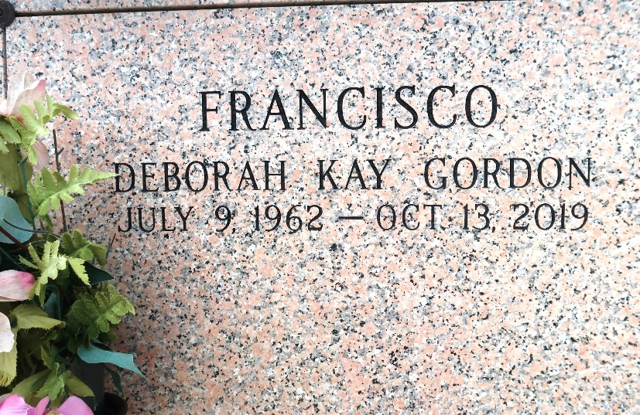

Deborah Kay Gordon Francisco passed away on Sunday, October 13, 2019 in LaPlace, LA at the age of 57. A native and life long resident of LaPlace. Beloved wife of Joseph Francisco Sr., loving mother of Amanda Roccaforte (Jeffery), Joseph Francisco Jr. (Jesseca) and Paige Francisco. Loving grandmother of Janie Roccaforte. Daughter of the late Ruth and Charles Gordon. Sister of Lynne Gordon.

Relatives and friends are invited to attend the Funeral Service at Millet-Guidry Funeral Home, 2806 W. Airline Hwy., LaPlace on Saturday, October 19, 2019 at 11:00 a.m. Visitation from 9:00 a.m. to 11:00 a.m. Followed by interment in St. John Memorial Gardens Cemetery.
Millet-Guidry Funeral Home, LaPlace, Louisiana
October 15, 2019

