Rose Marie (Williams) Francois
July 21, 1964 – March 29, 2013

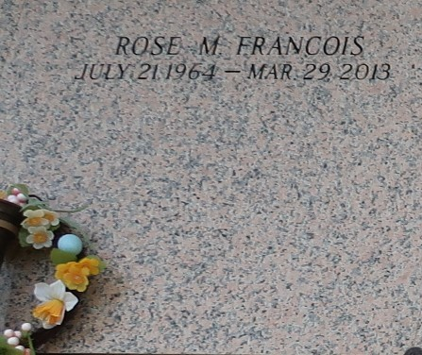

Rose Marie Williams Francois entered into eternal rest on Friday, March 29, 2013, at the age of 48 years old. Daughter of the late Rosalie and Rev. Medrick Williams, Sr. Wife of Timothy Francois, Sr. Mother of Brent (Gabrielle) Williams, Timothy Francois, Jr., and Daneille Pittman. Grandmother of Bryson, Breiya, Brianne and Brielle. Sister of Verna (Benjamin) Warren, Aline ( Rev. Edgar) Zeno, Marva (Melvin, Jr.) Joseph, Yvonne (Juansley) Smith, Norma Dorris, Marilyn (Samuel) Warren, Joyce (Mike) Bush, Marlene (Rev. Irvin) Watkins, Sheryl (Alexis) Pierre, Deloyd (Sharon) Williams, Lionel (Cheryl) Williams, Medrick Williams, Jr. and Gerald (Shalonda) Williams. Daughter-inlaw of the late Leborah Francois. Sister-in-law of Penny Howard, Alicia, Marvin and Clarence Francois. Also survived by a host of aunts, nieces, nephews, other relatives and friends.
Funeral services will be held on Saturday, April 6, 2013 for 11:00 a.m. at First Community Antioch Baptist Church, 10860 Highway 3125, Lutcher, La. Rev. Ferdinand Gaines, Jr. will be officiating. Visitation will be from 9:00 a.m. until time of service. Interment will be at St. John Memorial Gardens Cemetery, Laplace. Funeral entrusted to the Baloney Funeral Home, LLC, 1905 W. Airline Highway, Laplace, La. 985-224-8460.

The Times-Picayune, New Orleans, Louisiana
Apr. 1 to Apr. 5, 2013

