Jean (Deville) Fuselier
December 14, 1940 – July 27, 2021

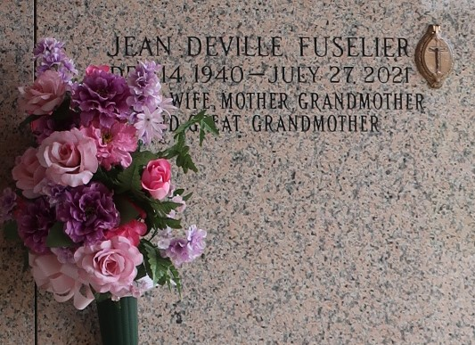
Photo by Team T Lo

Jean Deville Fuselier, beloved wife, mother, and grandmother, age 80, passed away on July 27th, 2021. She is survived by her loving husband, John E. Fuselier, Sr., her children, Rochelle Ory (R. J.), Jeannine Roussel (Mark), Monique Schloeffel (Glenn) and John E. "Johnny" Fuselier, Jr. (Shauna); her grandchildren, Christopher, Timothy (Victoria), Gabrielle, and Dominic Boesen; Austin (Ashley), Mason (Kira), Ryan (Elizabeth) and Jeanne Roussel; Nicole and Luke Schloeffel; Anjolina, Preston, Savannah and Mary Ann Fuselier; her step grandchildren, Katelyn Ammon (Brandon), Sean and Josh (Julie) Boesen, and Zachary Roussel; and her great grandchildren Penelope Boesen, Keller Roussel, Ory and Anders Ammon.
She was preceded in death by her parents, Curtis and Luther Weller Deville; and her brothers, Rayford and Burke Deville. Jean was born in Mamou, LA, attended Louisiana State University and later was a stewardess for Eastern Airlines. Her career was interrupted when she married John in 1961. After moving to La Place in 1977, Jean was a Real Estate Agent for Latter and Blum for several years. Jean cherished her family, especially her grandchildren and lived a life with emphasis on family and an example of unconditional love. Family and friends are invited to St. Joan of Arc Catholic Church, 529 W. 5th St., LaPlace, LA on Saturday, July 31, 2021 for visitation beginning at 12:15 PM followed by a Funeral Mass at 2:00 PM. Interment in St. John Memorial Gardens Cemetery, LaPlace.
Millet-Guidry Funeral Home, LaPlace, Louisiana
Contributed by Jane Edson

