Judson Worth Hanna, Jr.
November 27, 1961 – March 29, 2004

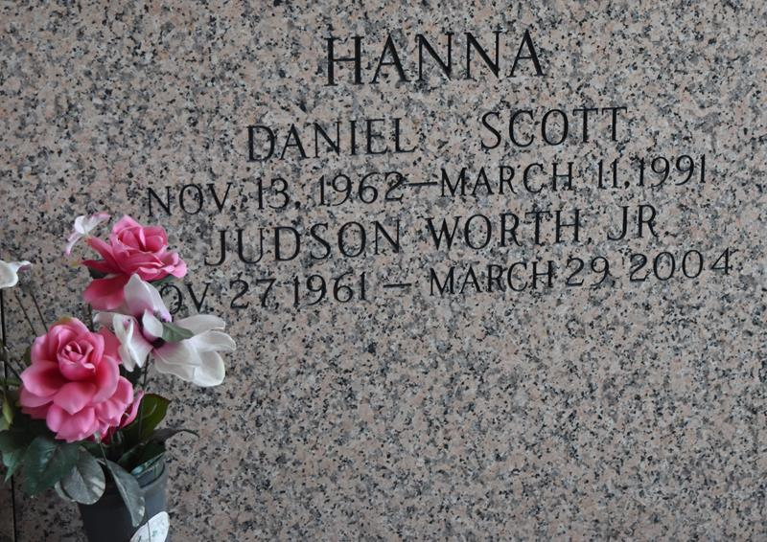

LAPLACE - Judson W. Hanna Jr., 42, died at 12:07 a.m. Monday, March 29, 2004.
A native of Baton Rouge, he was the beloved son of Janelle Colligan Hanna and the late Judson W. Hanna Sr. He attended St. Joan of Arc Catholic Church, De La Salle High and McNeese State University. He was a resident of LaPlace, and former resident of New Orleans, Lake Charles, and Ventress.
In addition to his mother, survivors include brothers, Mitchel and Jason Hanna; and aunts and uncles, Neal and Anna Mae Doucette, John and Lucille Colligan, Roger and Lettie Vanderzwagg, Walter and Carol Hanna, Nancy and Jerry Wilson, and Mary Frances Colligan Feller.
He was preceded in death by one brother, Scott Hanna; and his grandparents, Dick and Elethia Hanna, and Alex and Anna Mae Colligan.
His funeral will be at 10 a.m. Thursday, April 1, from St. Joan of Arc Catholic Church. Burial will be in St. John Memorial Gardens under the direction of Millet-Guidry Funeral Home, 2806 W. Airline Highway, LaPlace.
Visitation is 5-9 p.m. today and 8-9:45 a.m. Thursday in the funeral home.

American Press, Lake Charles, LA
Wednesday, March 31, 2004

