Col. Judson Worth Hanna Sr.
November 5, 1936 – May 4, 1989

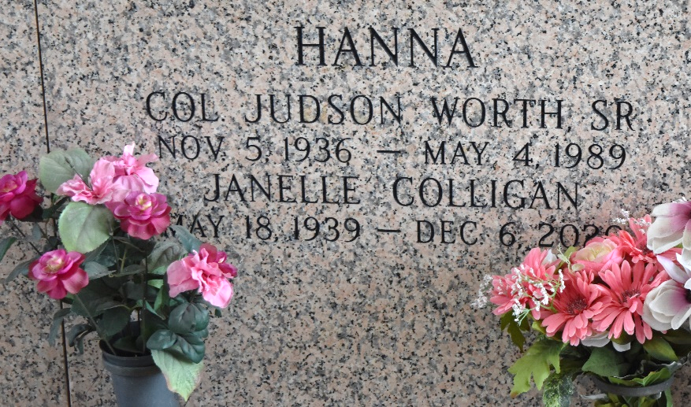

U.S., Department of Veterans Affairs BIRLS Death File, 1850-2020
Name Judson Worth Hanna
Gender Male
Birth Date 5 Nov 1936
Death Date 4 May 1989
SSN xxx
Enlistment Branch Army
Enlistment Date 31 May 1960
Discharge Date 4 May 1989
Page number 4

