Easter Howard
April 17, 1938 - December 6, 2024

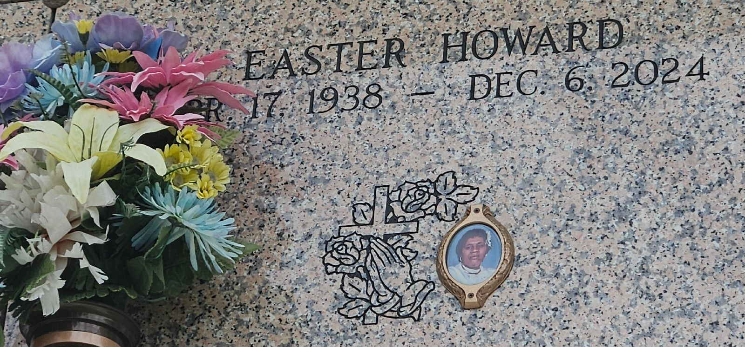
Photo by Team T-Lo

Easter was born on April 17, 1938, in Lucy, LA to Gustave Jack Howard, Sr. and Laura Baker Howard. The family later moved to LaPlace. Easter accepted the Lord as her personal Savior and was baptized in the Mississippi River at a young age. Easter spent her entire life serving God. She was a member of Mt. Calvary Baptist Church where she was a dedicated usher until her health failed, she was under the leadership of Rev. Dr. Freddie L. Howard, Sr. She was a good aunt to all of her nieces and nephews. Easter helped raise her four nephews, Rose Mary's sons, with her parents until they became young men.
Easter lived with her parents until they were called home to be with the lord. She later moved in with her sister Rose Mary and brother-in-law, Otis who cared for her until she passed. She is survived by her Siblings: Dr. Deloris Millet, Dr. Joyce Brown (Bro Randell Sr.), Rev. Dr. Freddie L. Howard, Sr. (Sis Sherry), Sis Rose Mary (Bro Otis Sr.), and Barbara Gibbs. God Children: Penny and Gary, Devoted nieces: Cheryl Dennis Dorris, Cindy H. Nicholas, and Roslyn Joseph, Devoted Nephews: Gerald Howard, Robert Joseph, Sr. and Benny Joseph, Jr. Easter is preceded in death by her parents Gustave Jack Howard, Sr. and Laura Baker Howard. Siblings: Gustave Jack Howard, Jr., Gladys Joseph, Mildred Dennis, Milton Jack Howard, Sr., Isabella Gerard, Evangelist Laura Helen Vampran, and Deborah Francois. Easter will be remembered for her friendly and outgoing personality and remarkable laugh. A celebration service honoring her life will be held on Saturday, December 14, 2024 at Mt. Calvary Baptist Church, 127 W. 3rd Street, LaPlace, LA 70068. Visitation begins for 11 a.m. followed by the service for 12 noon. Interment to follow at Saint John Memorial Gardens, 2205 W. Airline Hwy., LaPlace, LA 70068.

Treasures of Life Funeral Services, Gramercy, LA
December 11, 2024

