Joanna Maria (Brown) Jackson-James
February 28, 1971 - April 11, 2025

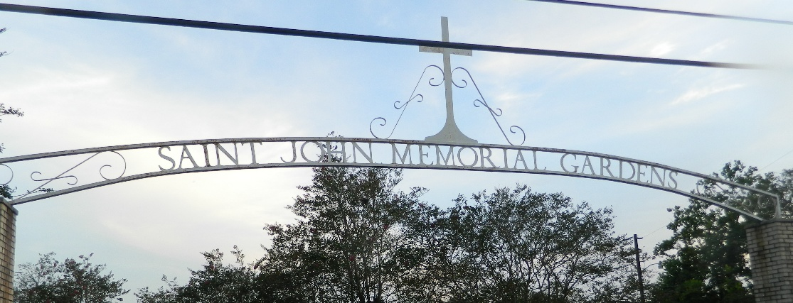

Born on February 28, 1971, in New Orleans, Louisiana, Joanna Maria Jackson-James was the cherished daughter of Joann Marie Brown and Gregory Brown, a loving sister to Jonathan Jackson, Larry Jones, Laron Jones, Sr., and Taber Davis, Sr., an extra-ordinary mother to Raymond James, Jr., Monteja’ James, and Raynard James, wife to Raymond James, Sr., and beloved friend and confidant to many.
She graduated from Tulane University, excelling as an honor student and leader, earning a Bachelor of Arts in Social Sciences and a Master of Liberal Arts. As an inducted member of Alpha Sigma Lambda, Theta Chapter, Joanna truly believed that education was not only one of the most valuable attributes, but a lifelong journey. Alongside her education, she pursued a successful career in youth advocacy, and that passion for advocacy was matched only by her commitment to helping others. Her allyship for specific causes, such as social justice, education, and being a champion for children, reflected her deep desire to make the world a better place for all. Joanna’s favorite quote was, “It’s all about the children.”
Joanna was a woman of many talents and interests, from her love of music and singing to her dedication to helping her village and giving back. She most enjoyed hosting and entertaining her family and enjoyed preparing and enjoying great delicacies, as well. She loved deeply, laughed often, and brought light to every room she entered. Her faith, resilience, and unwavering belief in justice inspired all who knew her. Even with such an eventful life filled with skills and pursuits, her greatest achievement of all was being a mother to her three beautiful children.
Throughout her life, Joanna was deeply committed to her faith and her community. Her dedication to continue to renew her faith and be a disciple of the Lord was felt by all who encountered her. She uplifted others with her unwavering belief in love, hope, and the everlasting love of God. She sang the praises of the Lord and ministered to others through many years performing in traveling choirs, her church’s choirs, and every day of her life.
She is survived by her children, Raymond Lewis James, Jr., Monteja’ Johanna James (Alex), and Raynard Jeremiah James; her parents, Joann Marie and Gregory Brown; siblings, Jonathan Jackson (Debrica), Larry Jones, Jr., Laron Jones, Sr. and Taber Davis, Sr.; and a host of nieces, nephews, and cousins, along with extended family and friends.
Though our hearts are heavy, we celebrate Joanna Jackson-James’s incredible life and the countless lives she touched. Her spirit, warmth, and love will live on forever in our hearts. Forever Lady Joanna. A Celebration of Life, Love, and Legacy will be held on Saturday, April 26, 2025 at Assembly Christian Church, 3550 W. Airline Hwy., Reserve, LA 70084 for 11am with visitation for 10am until service time. Entombment St. John Memorial Gardens 2205 W. Airline Hwy., LaPlace, LA 70068.

Treasures of Life Funeral Services, Gramercy, Louisiana
April 15, 2025

