Jamond L. James
July 3, 1990 – April 6, 2013
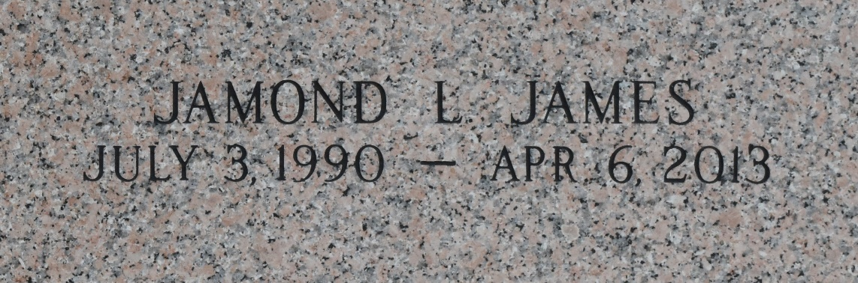

Suspect arrested in association with fatal shooting of Reserve man
RESERVE, La. - Deputies arrested a LaPlace man in connection with a Saturday night murder of a Reserve man, according to the St. John Parish Sheriff's Office.
Lorenzo Porter, 28, was arrested Wednesday in association with the death of Jamond James, 22.
Around 9:43 p.m. Saturday, James was fatally shot at the intersection of East 24th Street and Highway LA 44 in Reserve, deputies said.
Porter was booked with second degree murder, possession of a firearm by a felon, a bench warrant and an attachment. Porter's bond is $271,562.90.

CBS - 4 WWL, New Orleans, Louisiana
Thursday, April 11, 2013

