Rita Mae (Jones) Johnson
September 5, 1947 - September 15, 2025

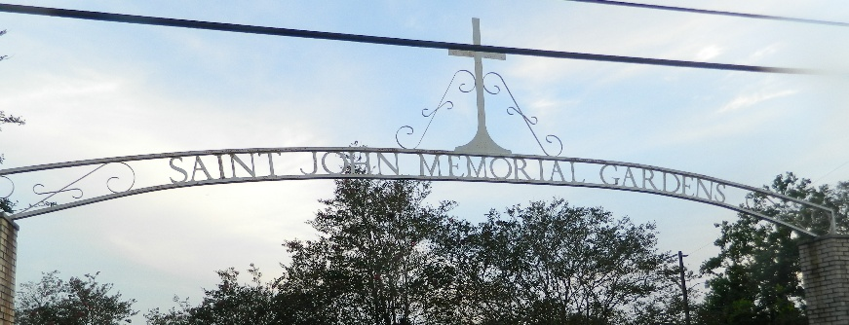

It is with both deep sorrow and warm reflection that we announce the passing of Rita Mae Jones Johnson, who took her leave from this world on September 15, 2025. Born to the late Wilson Sr. and Josephine Williams Jones in Plaquemine, LA on September 5, 1947, Rita was a beacon of light to those who knew her, illuminating the world with her unique charm, compassion, and her unforgettable Soul food with a dash of Cajun spice. In the words of Maya Angelou, "My mission in life is not merely to survive, but to thrive; and to do so with some passion, some compassion, some humor, and some style."
Rita embodied this philosophy in all she did. After several years working in the food service industry, Rita leveraged her passion for cuisine and her entrepreneurial spirit to establish her own successful business. Her culinary creations were a testament to her love for her Louisiana heritage and a way she connected with her community. Her gumbo was legendary, her red beans irresistible, and her sweet potato pies were a sweet reminder of her unwavering kindness.
Rita was a devoted mother to Alecia Johnson, Chandrika Johnson-Anderson (Armond), DeLois Johnson of New Orleans, LA, Danielle Johnson-Davis (Michael); (Bonus) Bianca Johnson of New Orleans, LA and a doting grandmother to Codi Clark, Dontriel Howard (Justin), De’Javon Taylor, Derion Savoie, Dr. Diamond Perri Nickelson, Leonard Harris III, La’Deja Harris, Sydney Duhe, Kyhren Brown, Gabrielle Guidry, Alicia Johnson, Rhiana Johnson, Darvi Johnson, and five great-grandchildren; she was preceded in death by her parents and three sons Dartania, Morial and Randy Johnson.
She poured her love into her family, nurturing them with the same fervor that she put into her cooking. Her wisdom, resilience, and infectious laughter have left an indelible mark on their lives, and her memory will forever be a source of comfort and inspiration. Rita's zest for life and her unwavering determination to live life on her own terms will be remembered by all who had the pleasure of knowing her.
As we mourn the loss of Rita, let us also celebrate her life and the many ways she enriched ours. The family invites all who knew and loved Rita Mae to join them in celebrating her life on Saturday, September 27, 2025 at Beech Grove Baptist Church, 117 Beech Grove Dr., Reserve, LA 70084. Visitation begins for 7:00am followed by the Celebration of Life, Love, and Legacy for 10:00am. Entombment St. John Memorial Gardens, 2205 W. Airline Hwy., LaPlace, LA 70068.

Treasures of Life Funeral Services, 315 E. Airline Hwy., Gramercy, LA
September 26, 2025

