Millie (Jones) Williams
August 29, 1935 – February 12, 2016
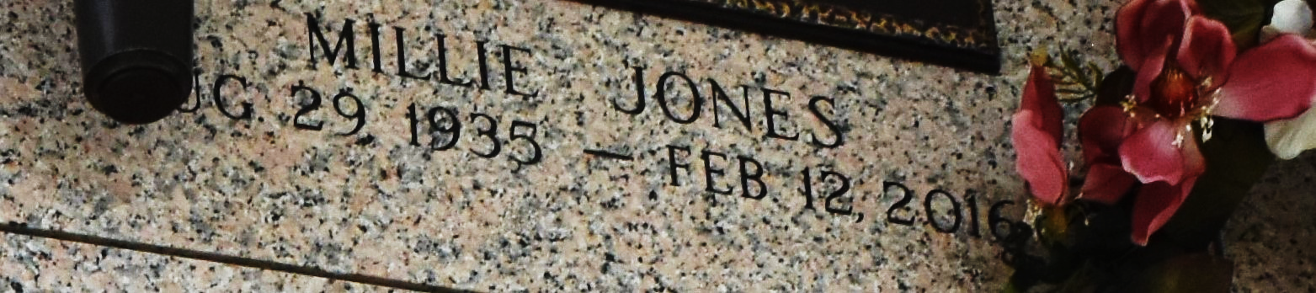

Millie Jones Williams, a native and resident of Garyville, La. departed this life on Friday February 12, 2016.
Wife of the late Eddie (Beanie) Williams Jr. Beloved mother of Corliss Williams, Paula (Freddie) Johnson, Penny Williams, Staria (Henry ) Anderson, Eddie (Sonji) Williams III, Edwin (Tinya) Williams, and Debbie Williams. Survived by 10 grandchildren, 5 great grandchildren, 2 sisters Ernestine Lee and Lillie Mae Brown, a host of nieces, nephews, relatives and friends.
Relatives and friends of the family are invited to attend the funeral services on Saturday Feb. 20,2016 at 11:00am at New Zion Christian Fellowship 216 West Main St. Gramercy, La. Visitation on Friday from 5-7pm at Treasures of Life Center for Life Funeral Services 315 E. Airline Hwy. Gramercy, La. And at the church after 9am on Saturday. Entombment St. John Memorial Gardens, LaPlace, La.

New Orleans Advocate, The (Louisiana)
Friday, February 19, 2016

