Rachel Ann Keating
December 16, 1966 – June 8, 2017

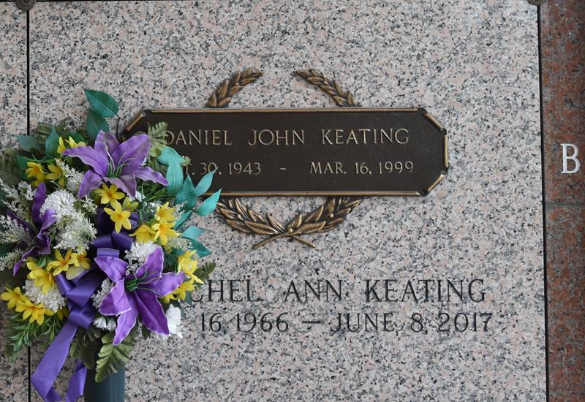

Rachel Ann Keating, 50, a resident of Cut Off, passed away Thursday, June 8, 2017.
Visitation will be held at Samart-Mothe Funeral Home Saturday, June 17, from 11 a.m. until funeral services. Funeral Services will be held at 1 a.m. Please wear a LSU shirt and jeans.
Rachel is survived by her two children, Victoria (Josh) Portugal and Christopher Schouest; mother, Bobbie Keating; brother, David (Rita) Keating; and many cousins and extended family.
Rachel was preceded in death by her father, Dan Keating; and grandparents, Robert and Shirley Jacob.
Rachel is a graduate of South Lafourche High School Class of 1984. She worked for West Jefferson Hospital for many years. She was an avid LSU football fan and you could always catch her under those Saturday night lights in Tiger Stadium.
Samart-Mothe Funeral Home in charge of arrangements.

Daily Comet, Thibodaux, Louisiana
Thursday, June 15, 2017

