Raymond F. Kennair Jr.
November 2, 1939 – November 29, 2017

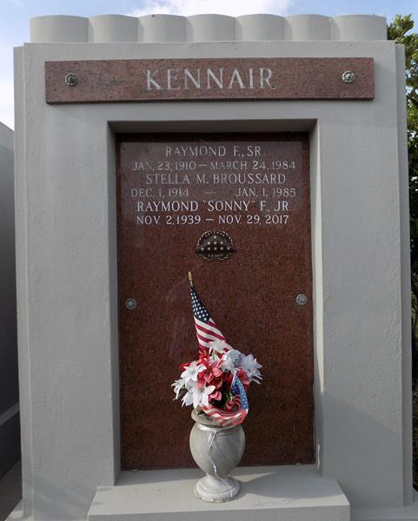

Raymond "Sonny" Kennair, Jr., a resident of LaPlace for the past 50 years passed away Wednesday night November 29, 2017. Ray was born in New Orleans on November 2, 1939, but was raised in Carencro, Louisiana. After High School he enlisted in the U.S. Navy and served from '58 to '67. He was a first class radioman and served on landing craft during the Vietnam War.
While stationed at the naval base in Yokosuka, Japan he met his wife of 54 years Mitsuko Kimura Kennair. She, along with their three sons, Kenneth, Kevin, Kyle, and his sister, Carol Broussard, survive him. Also survived by 4 grandchildren, Aiden, Andrea, Jackson, and Lyla; 2 nephews, Kent and Kirk; brother-in-law, Walter; and 2 daughters-in-law, Yvette and Soña. Upon moving to LaPlace he started working for T.L. James & Co. and retired 33 years later as a safety engineer.
Relatives and friends are invited to attend the Memorial Service at Millet-Guidry Funeral Home, 2806 W. Airline Hwy., LaPlace on Tuesday, December 5, 2017 at 11:00 a.m. Visitation from 9:00 a.m. to 11:00 a.m. Inurnment in St. John Memorial Gardens Cemetery.

Millet-Guidry Funeral Home, LaPlace, Louisiana
December 2, 2017

