Minnie Ola Kimler
July 24, 1930 – June 22, 2008

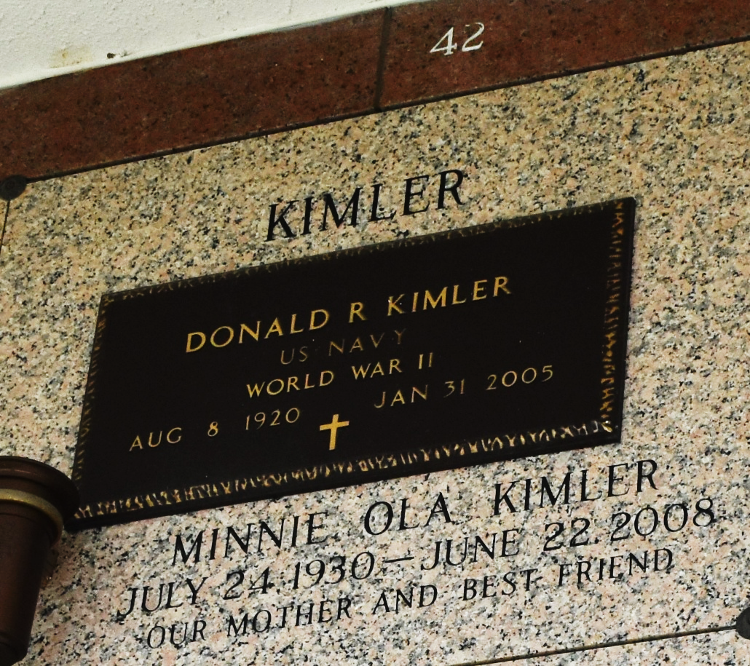

Minnie Kimier (sic - Kimler) on Sunday, June 22, 2008 at 9:35pm. Beloved wife of the late Donald Kimier. Mother of Mary Jane Giglio and husband Sal and Myrtle Simoneaux and husband Paul Sr. Grandmother of Paul Simoneaux Jr. and wife Dawn. Great grandmother of Casey and Callie Simoneaux. Sister of Mildred Hoffpauir, Ginger Maher and many other brothers, sisters, nieces and nephews. Age 77 years, a native of Natchez, MS and resident of LaPlace, LA.
Relatives and friends of the family are invited to attend services. Visitation at Millet-Guidry Funeral Home, 2806 W. Airline Hwy, LaPlace, LA on Thursday, June 26, 2008 from 8:30am until 10:00am, followed by Religious Services at the Funeral Home Chapel at 10:00am. Burial in St. John Memorial Gardens Cemetery, LaPlace, LA.
Times-Picayune, The, New Orleans, Louisiana
Wednesday, June 25, 2008

