Delores (Watkins) Lennix
April 20, 1937 - December 13, 2024

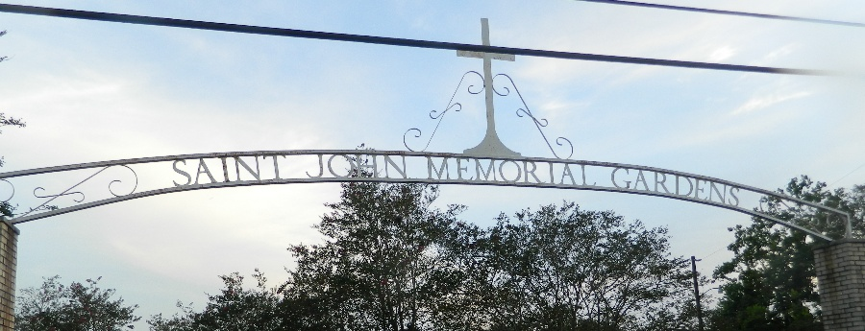

Delores Watkins Lennix, affectionately known as "Tokay", was born on April 20, 1937, in LaPlace, Louisiana to the late Tillman and Julia Banks-Watkins.
She accepted Jesus as her Lord and Savior at a young age and was baptized at Greater Morning Star Baptist Church, under Reverend Joseph Warren Sr. She later joined the fellowship of Mt. Nebo Baptist Church as a member under Reverend Augustus G. Brown Jr. As a member of Mt. Nebo, Delores was a devoted choir member and a dedicated church mother.
Delores completed Charity's Nursing Program and dedicated her life to serving others in healthcare as a nurse for over thirty years. Her nursing career included caring for individuals at Charity Hospital, St. John the Baptist Heath Unit, and St. John the Baptist Head Start and Early Childhood Program, where she ultimately retired. Delores's calling to care for others through the field of nursing continues to evolve, as she has pioneered a legacy of healthcare providers that continues to expand through her grandchildren and generations to come.
Delores wed the love of her life, Mitchell Lennix Jr. (Billy) on June 20, 1955. God blessed their union with 8 children: Reginald Lennix, Loyce Watson (Edwin), Joyce Farlough (Harris), Alvin Lennix, Eileen Lennix (Richard), Dwight Lennix, Paulette Hargrave (David Sr.), Vada Bridges (Darrell Sr.) and bonus daughter, Jarita Julien. She leaves behind 22 grandchildren (Rondell, Hernandez, Shawn, Edwin, Ryan, Randi, Ashley, Darianne, Jessica, Dwight, Tanyaneka, Alexandria, Brandon, Andre, Kyron, Emmanuel, Jalin, David II, Terrilon, Tai and Darrell Jr.), 62 great-grandchildren and 9 great-great-grandchildren.
Delores transitioned to her heavenly resting place on Friday, December 13, 2024 surrounded by loved ones. She is preceded in death by her parents: Tillman and Julia Banks-Watkins, her husband, Mitchell Lennix Jr., their son Alvin Lennix, and her brothers: Jim, Willie, Rosevelt, Louis and Forest Watkins.
She will forever be known, loved and remembered as an outspoken, independent, intelligent woman who was known as the matriarch of the Lennix family. She opened her heart and kitchen to all those in need. She did not hesitate to share the greatness of God to anyone she encountered. Her love, strength, wit and honest words will remain the staple of her personality etched into the hearts and minds of all those that knew her.
A Celebration of Life will be held at Mt. Nebo Baptist Church, 198 W. Second Street, LaPlace, LA on Saturday, December 28, 2024. Visitation begins for 10 a.m. followed by service for 11a.m. Entombment: Saint John Memorial Gardens, 2205 W. Airline Hwy., LaPlace, LA.

Treasures of Life Funeral Services, Gramercy, Louisiana
December 25, 2024

