Sallie (Joseph) Lightell
August 6, 1955 – August 20, 2024

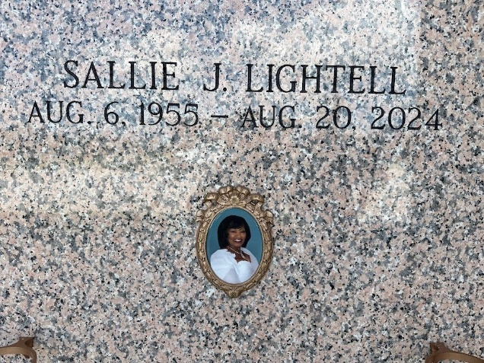
Photo by Team T-Lo

Sallie J. Lightell was born on August 6, 1955 in New Orleans, LA to the late Etienne Sr. And Sallie Ann Joseph. Sallie grew up in Reserve, LA with her 6 siblings.
Sallie accepted Christ as her savior and was baptized at an early age by the late Pastor Henry Robinson of Mt. Zion Baptist Church #1 of Garyville, LA. Sallie graduated from Leon Godchaux High School in Reserve in 1973. She was then crowned Sweetheart of 1973.
Sallie was blessed with 5 children. From her first marriage, Cantrell Keller Sr. From her second marriage, Carey McNeil Jr. In 1987, she married Gaylen Lightell Sr and from this union she was blessed with Lynell Lightell, Andrea Miller, Kaitlynn Lightell and three bonus children: Gaylen Jr., James and Jacobi Lightell.
Sallie was loved by many and was everyone’s favorite. She was very outspoken and straight-forward but we all knew it was how she expressed her love to everyone. Sallie had a huge heart and a great love for children. She enjoyed being the woman of the house and providing for her husband and family until her departure.
Sallie Lightell leaves to cherish her loving memories, her devoted husband, Gaylen Lightell Sr. of Reserve, LA. Her children: Cantrell (Naomi) Keller of LaPlace, LA. Carey (Sandra) McNeil Jr of St. Augustine, FL. Lynell Lightell of Kennesaw, GA. Andrea (Eric) Miller of Norco, LA. Kaitlynn Lightell of Reserve, LA. Bonus children: Gaylen (Terenza) Lightell Jr of Destrehan, LA., James Lightell of Prairieville, LA, and Jacobi Lightell of Wichita, Kansas. 22 grandchildren and 3 great grandchildren. Her Siblings: Pastor Edgar(Linda) Joseph of Avondale, LA and Michael (Lesa) Joseph of Fort Worth, TX. Brother-in-law, Adam Cooper Jr of Gramercy, LA. Sister-in-law, Vanessa Lightell of Port Sulfur, LA. God-children: Levi Byers Jr. and Erica Smith and a host of nieces, nephews, relatives and friends. On August 20, 2024, Sallie J. Lightell went home to be with the lord.
Sallie was preceded in death by her parents. Her siblings: Emma (Irvin) Gomez, Etienne Jr., Alfred Joseph, and JoAnn Cooper. Her mother and father-in-law, Ida and Luke Lightell.
A celebration service honoring her life and legacy will be held on Saturday, August 31, 2024 at House of Prayer Church, 900 Terrace St., Destrehan, La 70047. Visitation begins for 9am followed by service for 11am. Pastor Edgar Joseph, officiating. Entombment to follow at St. John Memorial Gardens, 2205 W. Airline Hwy, Laplace, La 70068.

Treasures of Life Funeral Services, Gramercy, Laouisiana
August 31, 2024

