David A. Lopez
June 27, 1961 – June 12, 2004

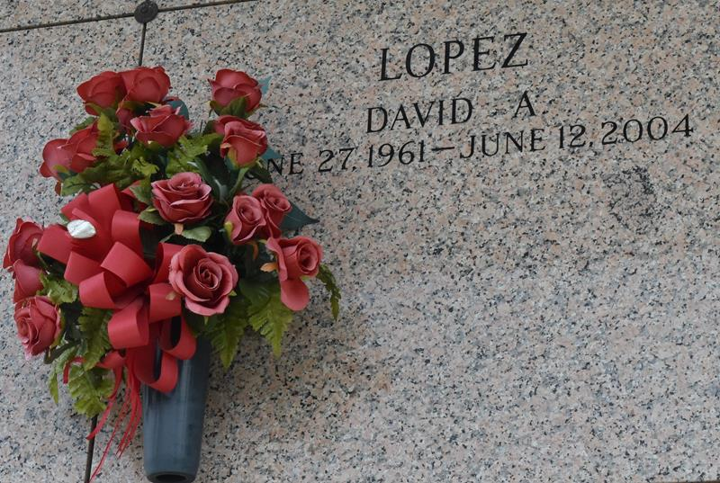

David A. Lopez, a tile layer, died Saturday of a massive heart attack at his home. He was 42. Mr. Lopez was born in St. Antonio and lived in LaPlace for 17 years.
Survivors include his wife, Janet Lopez of LaPlace; three sons, David Davis of San Antonio and Jake Heckathorn and Dylan Lopez of LaPlace; a daughter, Brandy Lopez of LaPlace; his mother, Teresa Lopez; seven brothers, Arturo Lopez of Kenner, Daniel Lopez of LaPlace, Roland Lopez of Kenner, Ernest Lopez of LaPlace, Julian Lopez of Metairie, Joe Lopez of San Antonio and Juan Lopez of Kenner; and three sisters, Sylvia Lopez of Metairie, Mary Sosa of LaPlace and Olga Lopez of Panama City, Fla.
A funeral will be held Friday at 10 a.m. at Millet Guidry Funeral Home at 2806 W. Airline Highway in LaPlace. Visitation will be held today at 5 p.m. and Friday at 8 a.m. at the funeral home. Burial will be in St. John Memorial Gardens.
Times-Picayune, The (New Orleans, LA)
Thursday, June 17, 2004

