Randy K. Martin
November 3, 1950 – April 12, 2015
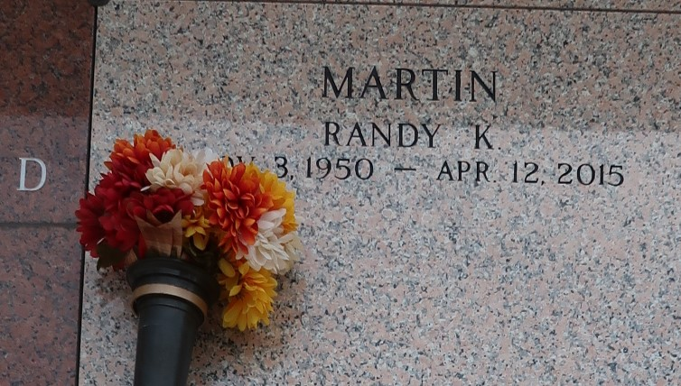

Randy Martin on Sunday, April 12, 2015, at his home in LaPlace, LA.

Son of Hilda U. Martin and the late Walter L. Martin. Husband of Trusie B. Martin. Father of Joshua and Jesse Martin. Step Father of Thomas Kleven and Travis McDuffie. Brother of Sherry Dupuy (Dave), Debra Wenger (Tom), Russell Martin (Linda) and the late Kelly Eichler. Also survived by numerous grandchildren, and a host of nieces, nephews, cousins, other relatives and friends. Age 64 years. A native of Honolulu, Hawaii and a resident of LaPlace, LA.

Relative and friends of the family, also members of LaPlace Church of Christ and all neighboring churches are invited to attend a visitation at LaPlace Church of Christ, 1909 West Airline Highway, LaPlace, LA, on Monday, April 13, 2015, from 5:00 PM until 7:00 PM and a Graveside service on Tuesday, April 14, 2015, at St. John Memorial Garden, 2205 West Airline Highway, LaPlace, LA, at 10:00 AM. SERVICED BY ROBOTTOM.

New Orleans Advocate, The (LA)
Tuesday, April 14, 2015

