Joy (Scharwath) Monica
October 5, 1943 - April 21, 2025

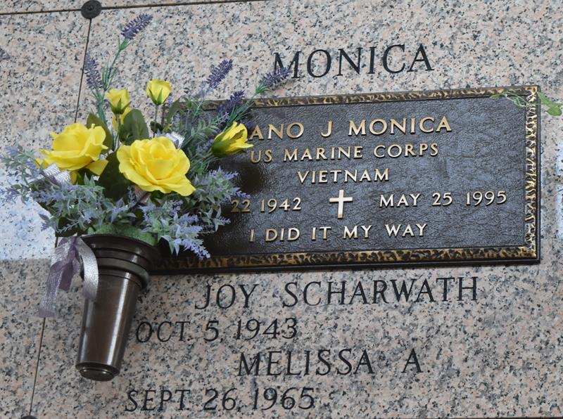

Joy Monica, a lifelong resident of Garyville, passed away on Monday, April 21, 2025 at the age of 81.
Beloved wife of the late Epifano “Fano” Monica. Loving mother of Melissa Monica. Daughter of the late Herbert Scharwath and Ethel Siears Scharwath. Sister of Aleta “Cookie” Scharwath, Frank Scharwath, the late Faith Coneglio (the late George), David Scharwath, Ethel Audiffred (the late Raymond), George Scharwath (Annette), and Frank Herbert “Brother” Scharwath, Jr. Niece of Hilda “Snook” Kilburn. Daughter-in- law of the late Frank Monica and Vita Navarra Monica. Sister-in-law of Cookie Accardo (Sammy, Sr.), Maria Stein (Wayne), Carl Monica, Frank Monica (Nancy), the late Phyllis Himel (the late O’Neil), Anna Monica, and Anthony Monica (Linda). Also survived by numerous nieces and nephews.
Joy always put her love of Jesus and the church first. She was an active member of the Cursillo Movement in Opelousas, LA. She worked 44 years as an accountant for Kellogg Brown and Root Construction Company. She enjoyed dancing, going for walks, reading, and sharing a glass of Merlot with friends and family. Joy was an avid lover of pets especially her dogs Charlie, Alex, Bootsie, Rocketman, Cowboy, Roscoe, and her cat Cosmo.
In lieu of flowers Joy requested donations be made to an animal rescue haven.
Relatives and friends are invited to attend the Visitation and Funeral Mass at St. Hubert Catholic Church on Thursday, April 24, 2025. Visitation from 9:00 am- 11:00 am with the Funeral Mass at 11:00 am. Burial to follow at St. John Memorial Gardens.

Rose Lynn Funeral Home, Lutcher, Louisiana
April 30, 2025

