Marie Jeannette (Landry) Neely
April 20, 1938 – July 24, 2004
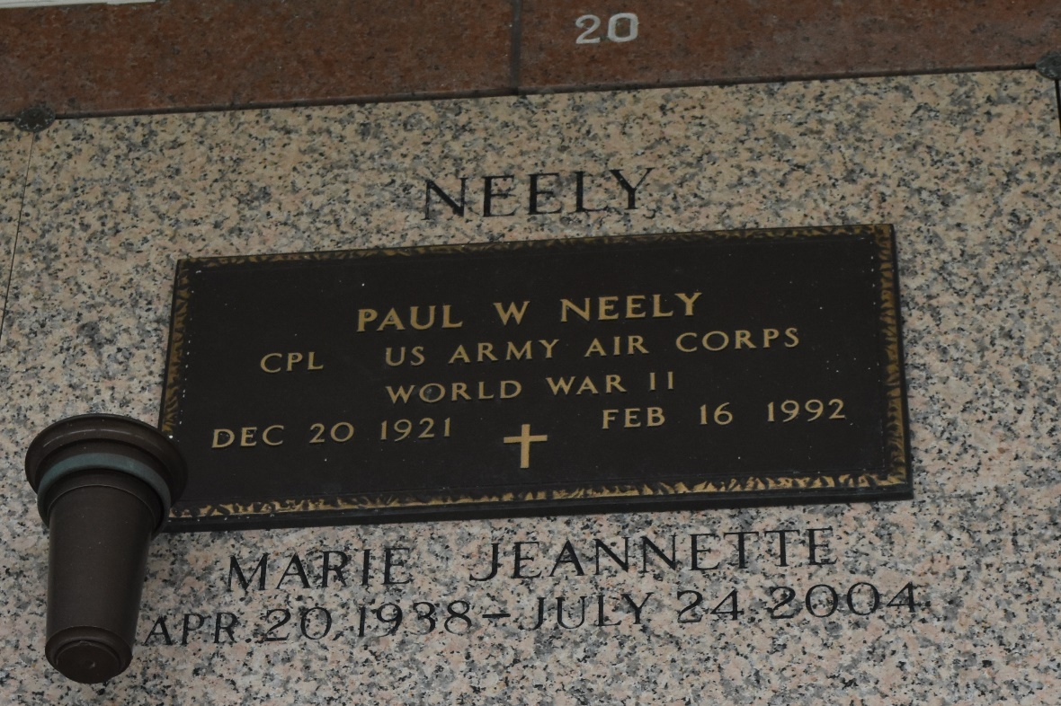

Marie J. Neely, a homemaker, died Saturday at her home of complications after surgery. She was 66.
Ms. Neely was born in Breaux Bridge and lived in LaPlace for the past 27 years.
Survivors include three sons, Clint Placette and Melvin and William McCurley; a daughter, Susanne Trafficano; a stepdaughter, Marsha Bradburry; two brothers, Ned and Paul Leon Landry; a sister, Sylvia Landry; and seven grandchildren.
A memorial service will be held Thursday at 7 p.m. at First United Methodist Church, 301 Bamboo Road, LaPlace. Burial will be private. United Funeral Service is in charge of arrangements.

Times-Picayune, The (New Orleans, LA)
Wednesday, July 28, 2004

