Janice (Ockman) Oncale
December 11, 1936 – January 17, 2000
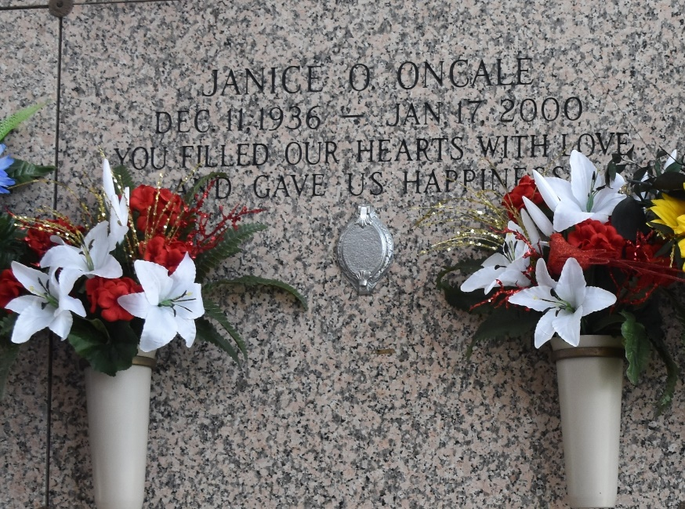

LAPLACE - Janice Ockman Oncale, a native of Vacherie and resident of St.
John Parish, died Jan. 17.

She was the wife of Paul J. Oncale and mother of Tracy Luminais, Trina Luminais and Trudy Trepagnier.
She was also the daughter of the late Charles and Amy Ockman and sister of Hazel Tamplain, Ruby Brignac, Marion Keating and the late Francis St. Martin.
She is also survived by four grandchildren.
Services are today at 10 a.m. in the chapel of Millet-Guidry Funeral Home, LaPlace, with interment at St. John Memorial Gardens, LaPlace. Visitation starts at 8 a.m.

L'Observateur (La Place, LA)
Wednesday, January 19, 2000

