Carol G. Owen
January 28, 1933 – November 26, 2000
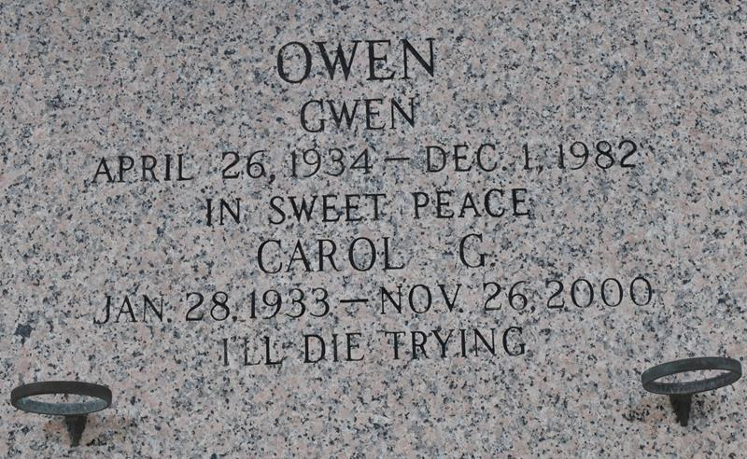

Mr. Carol G Owen, 67

Carol G. Owen, a maintenance superintendent, died Sunday of peritonitis at Kenner Regional Hospital. He was 67.
Mr. Owen was born in Red Boiling Springs, Tenn., and lived in LaPlace for 27 years. Survivors include his wife, Yvonne Rogers Owen; a son, Tim Owen of Destrehan; a daughter, Judy O. White of Decatur, Ill.; five stepsons, Dennis and Benny Parker, both of Galvez, Kenneth and Scott Parker, both of Covington, and Brian Keith Parker of Birmingham, Ala.; a stepdaughter, Donna Ellsworth of Susan Moore, Ala.; a brother, Ronal Owen of Tompkinsville, Ky.; a sister, Doris O. Baker of Fort Worth, Texas; five grandchildren; 11 stepgrandchildren; three great-grandchildren; and two stepgreat-grandchildren.
A service will be held today at 10 a.m. at Millet Guidry Funeral Home, 2806 W. Airline Highway, LaPlace. Visitation will be at 9 a.m. Burial will be in St. John Memorial Gardens, LaPlace.

Times-Picayune, The (New Orleans, LA)
Tuesday, November 28, 2000

