JoAnn (Juneau) Reech
August 2, 1937 - August 18, 2024

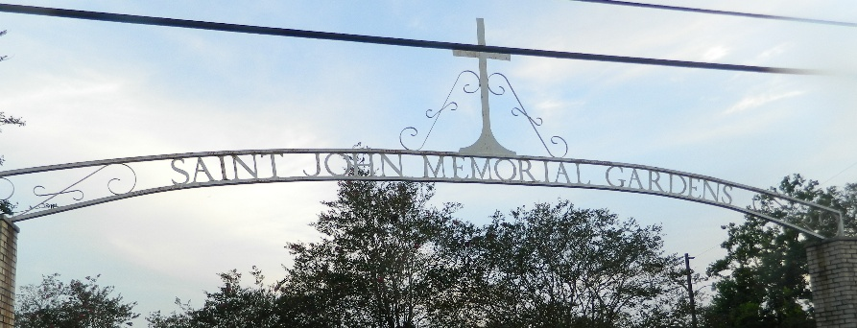

JoAnn Juneau Reech passed away on Sunday, August 18, 2024 at the age of 87. She was a native of New Orleans and a resident of LaPlace and most recently resided at The Parc Assisted Living in Gonzales, LA.
Beloved wife of the late George Reech. Loving mother of Diedre Lyn “Missy” Reech Gonor (John) and Cherie Gaye Reech Lasquety (Ludovic). Grandfather of Tori Alyssa Gonor Perret (Ashton), Dominic Marcel Lasquety, Braeden Joseph Lasquety and Cameron Paul Lasquety. Great grandmother of Christian Jacob Perret.
Daughter of the late Clarice Bordelon Juneau and Belezere J. Juneau. Sister of William Juneau (Sylvia), and the late Billy Ray Juneau, Michael J. Juneau, James Juneau, Glerma Dee Juneau Jeansonne. Also survived by many nieces, nephews and her special friends at The Parc.
The family would like to give a special thank you to the staff of The Parc Assisted Living Center and ACG Hospice for the loving care provided to JoAnn.
Relatives and friends are invited to attend the Funeral Service at Millet-Guidry Funeral Home, 2806 West Airline Hwy, LaPlace LA 70068 on Saturday, August 24, 2024 at 11:00 a.m. Visitation will be held from 9:00 a.m. until time of service. Interment will follow in St. John Memorial Gardens Cemetery.

Millet-Guidry Funeral Home, LaPlace, Louisiana
August 21, 2024

