Doris (Morris) Robertson
January 16, 1940 – May 26, 2025

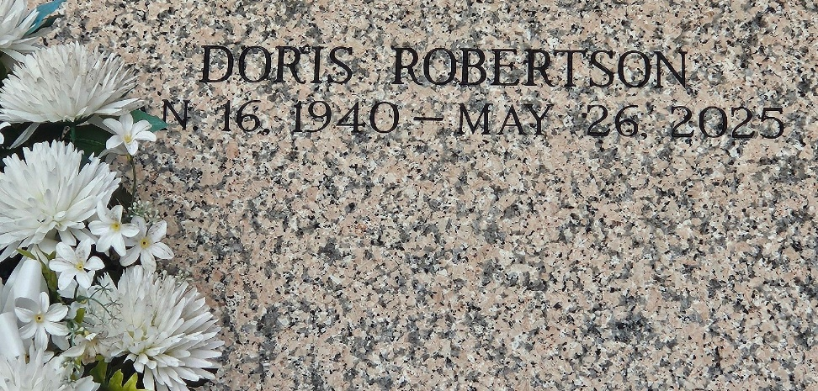
Photo by Team T-Lo

Doris Robertson, born on January 16, 1940, to Joseph and Flossie Morris, entered the heavenly gates to be with her Lord and Savior, on May 26, 2025 at Twin Oaks Nursing Home, Laplace, LA, leaving behind a legacy of love, faith, and service. A devoted wife, mother, sister, and servant of Christ, Doris was a cornerstone of her family and community.
Doris was united in holy matrimony to Willie Robertson, Jr., and together they shared many blessed years of companionship and love. Their union was graced by the gift of four children: Debra, Margaret, Willie, III, and Nolan. Doris cherished her role as a mother and took immense joy in nurturing her family with love and faith.
A lifelong servant of the Lord, accepted Jesus in her life in the late 60s and was baptized by the late Rev. Samuel Jones, Sr., at Providence Baptist Church #1. Doris was a dedicated member of Providence Baptist Church in LaPlace, where she served faithfully as a deaconess and mother of the church. Her unwavering faith, wisdom, and kindness were a source of inspiration to everyone in the congregation. Through her service, she touched countless lives and exemplified the true spirit of Christian love and humility.
Doris leaves to cherish her precious memory her beloved sister, Margaret Harper, wife of the late William Harper; her devoted daughters, Debra (Pastor Earl Gerard) and Margaret (Kevin Williams); two sons Willie Robertson, III (Devana) and Nolan Robertson (Erica); eight grandchildren, thirteen great-grandchildren, one great-great-grandchild, and a host of nieces, nephews, cousins, and friends who will forever hold her in their hearts.
She was preceded in death by her devoted parents, Joseph and Flossie Morris; her loving husband, Willie Robertson Jr.; her dear sister, Audrey Batiste (Raymond Batiste) and her brother Willie Morris (Sarah Lee Morris); and her cherished granddaughter, Markeshia Williams. Though their earthly presence is missed, Doris rejoins them in the eternal embrace of God's kingdom.
Doris Robertson’s life was a testament to her faith in God and her love for her family and community. She will forever be remembered as a beacon of light, whose legacy will continue to shine in the lives of all who were blessed to know her. "Well done, thou good and faithful servant: thou hast been faithful over a few things, I will make thee ruler over many things: enter thou into the joy of thy Lord." – Matthew 25:23
A Celebration of Life will be held on Saturday, June 14, 2025 at Providence Baptist Church #1, 228 Pine Street, La Place, LA 70068. Visitation begins for 10a.m. with service following for 11a.m. Entombment at St. John Memorial Gardens, 2205 W Airline Hwy, Laplace, LA 70068.

Treasures of Life Funeral Services, Gramercy, Louisiana
June 13, 2025

