Norman Bain Ross Sr.
June 29, 1930 – September 27, 2005

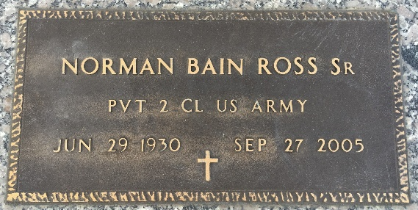
Photo by Team T-Lo

U.S., Department of Veterans Affairs BIRLS Death File, 1850-2020
Name Norman Bain Ross
Gender Male
Birth Date 29 Jun 1930
Death Date 27 Sep 2005
SSN xxx
Enlistment Branch Army
Enlistment Date 10 Jul 1951
Discharge Date 19 Dec 1951
Page number 2
**
Texas, U.S., Birth Certificates, 1903-1932
Name Norman Bain Ross
Gender Male
Birth Date 29 Jun 1930
Birth Place Dallas, Dallas, Texas, USA
Father James Nueno Ross, age 40
Mother Marie Elizabeth Fluette, age 33, 4 of 4 children living

