Ronnie J. Scallan
October 17, 1964 – May 28, 2025

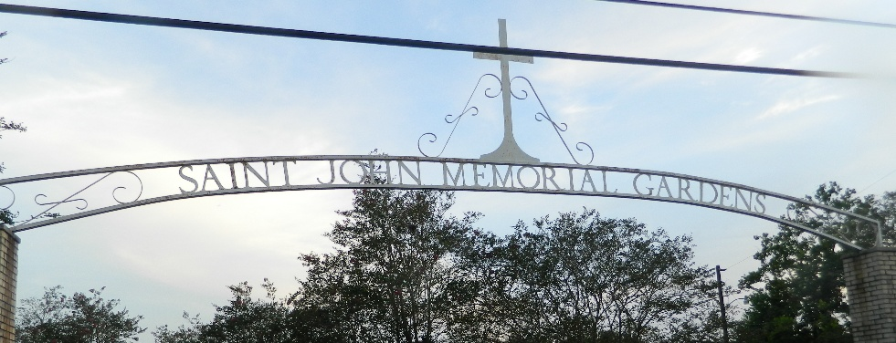

Ronnie J. "Blue" Scallan passed away at his residence on Wednesday, May 28, 2025 at the age of 60. He was born in Lutcher, LA and was a resident of Ponchatoula, LA.
Ronnie owned and operated Ronnie Scallan Roofing. He enjoyed cooking, camping, and his trips to Talladega and Daytona Motorsports. Ronnie also enjoyed taking care of his dogs.
Blue was preceded in death by his partner of 40 years, Jennifer Jenkins.
Beloved son of Dorothy Scallan and the late Benoit J. Scallan. Brother of Gregory B, Scallan (Rhonda), Elizabeth S. Blank, Jon Michael Scallan (Ann) and Rodney J. Scallan (Kathy). Uncle of Shane Scallan, Christina Scallan, Godson Raymond "R.J." Blank, Jr., Erica DeRouen (Aaron), Michelle Baggett (Kevin), Courtney Scallan, and Joshua B. Scallan. Also survived by 11 great nieces and nephews and his former sister-in-law, Beatriz Scallan.
Relatives and friends are invited to attend the Funeral Service on Friday, June 6, 2025, at Millet-Guidry Funeral Home, 2806 W. Airline Hwy., LaPlace. Visitation will be held from 9:00 a.m. to 11:00 a.m. with the Funeral Service to immediately follow the visitation at 11:00 a.m. Interment in St. John Memorial Gardens Cemetery.

Millet-Guidry Funeral Home, LaPlace, Louisiana
Jun. 2, 2025

