Mose Simmons Sr.
1936 – January 13, 2003
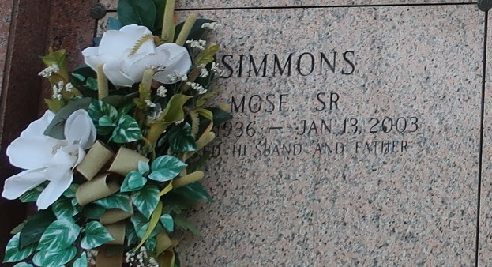

Mose Simmons, Sr. Of Reserve, LA, passed away At River Parishes Hospital, Laplace, LA On Mon., Jan. 13, 2003.
Beloved Husband Of Verlina Dickerson Simmons. Son Of The Late Nathaniel And Louiza Simmons. Father Of Mose Simmons, Jr., Andre Simmons, Sr., Rev. Carla Ceaser And Galyn Simmons Jones. Brother Of Frances S. Howard, Alma S. Hayes, Preston Joseph Jr., Helen Simmons, Gloria S. Fields.
Preceded In Death By '4' Sisters, '4' Brothers And Father-In-Law, William 'Bill' Dickerson. Son-In-Law Of Edna Dickerson.
Also Survived By Sons And Daughters-In-Law, '11' Grandchildren, Sisters And Brothers-In-Law, Nieces, Nephews, Cousins And Friends. A Native Of Convent, LA And A Resident Of Reserve, LA. Age 67 Years.
Relatives And Friends Of The Family, Also Pastor, Officers And Members Of The Beech Grove B.C. And Neighboring Churches, Employees Of Boh-Bros. Construction Are Invited To Attend The Funeral Services On Saturday, January 18, 2003 At 12:00 'Noon' From The Beech Grove B.C., 117 Beechgrove Dr., Reserve, LA. Rev. Wesley Anderson Officiating. Entombment St. John Memorial Gardens-Laplace, LA. Visitation At The Church After 9:00 Am On Saturday.

The Times-Picayune, New Orleans, Louisiana
January 17, 2003

