Sherman Joseph Simoneaux Jr.
August 22, 1958 – November 9, 2024

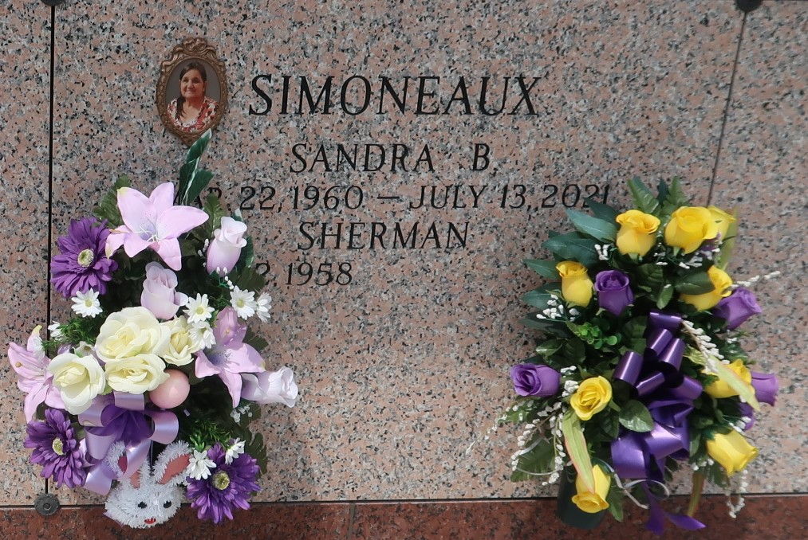

Sherman Joseph “Sugarfoot” Simoneaux, Jr., resident of LaPlace, was born August 22, 1958 and passed away November 9, 2024 surrounded by family.
He enjoyed hunting with his family and friends, growing his tomato garden and cooking wildlife. He loved spending time with his grandchildren and was always joking with everyone.
He is survived by his children Melissa Simoneaux, Sherman Simoneaux III, Michael Simoneaux, Felicia Simoneaux, and Amanda Simoneaux; his grandchildren Damon, Dylan, Gunner, Buck, Drake "Buddy", Michael Jr., Ryleah, Maverick, RaeLynn, Gabrielle, Jeremy, Jacob, Destiny, Blake Jr., Madison, and Nicholas; step grandchildren Elizabeth, Reality and William; great grandchildren Hudson and Zoro; brothers Tony, Calvin, and Darryl; sisters Simona and Renette; his only godchild Layla; and numerous of nieces and nephew.
He is preceded in death by his wife of 46 years Sandra Simoneaux; his parents Sherman Simoneaux Sr. and Yvonne Tabb; brothers Gene, Kelly, and Danny; sister Celeste, daughter Laura Simoneaux; and in laws Hubert and Mary Ann Bourgeois.
The family would like to thank Samatha Pierson for the care and support you have given and also his hospice nurses he had during his illness.
Relatives and friends are invited to attend the Visitation and Funeral Service. Visitation will be held at Rose Lynn Funeral Home, 1870 Cabanose Ave., Lutcher on Friday, November 15, 2024 from 5:00 p.m. to 8:00 p.m. and on Saturday, November 16, 2024 from 9:00 a.m. to 11:00 a.m. followed by a Funeral Service at 11:00 a.m. Interment in St. John Memorial Gardens Cemetery, LaPlace, LA. A Bereavement will be held after the interment at his niece, Ashley’s House, 263 Anthony F Monica St., Garyville, LA 70051.

Rose Lynn Funeral Home, Lutcher, Louisiana
November 14, 2024

