A. Ruth (Adams) Smith
August 14, 1919 – February 12, 2006

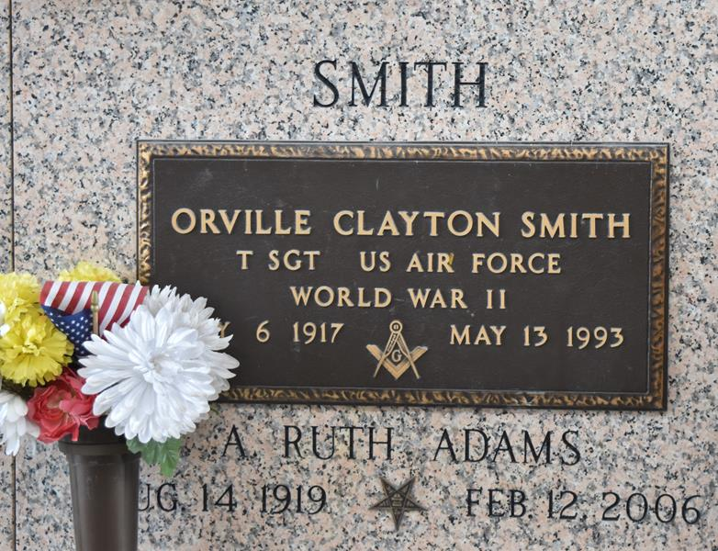

A. Ruth Smith died on Sunday, February 12, 2006.

Beloved wife of the late O. C. Smith, mother of Gary Smith and Karen Lampton. Also survived by five grandsons and one granddaughter, three great-granddaughters and one great-grandson.

Age 86 years. A native of Louisiana and a resident of LaPlace, LA.

Relatives and friends of the family are invited to attend the services. Visitation at the Millet- Guidry Funeral Home, 2806 West Airline Highway, LaPlace, LA on Wednesday, February 15, 2006, from 9:00 a.m. to 10:00 a.m. Graveside service at St. John Memorial Gardens, LaPlace at 10:00 a.m.

Times Picayune, New Orleans, Louisiana
February 15, 2006

