Bertha Mae (Kelson) Smith
August 3, 1932 – December 1, 2021

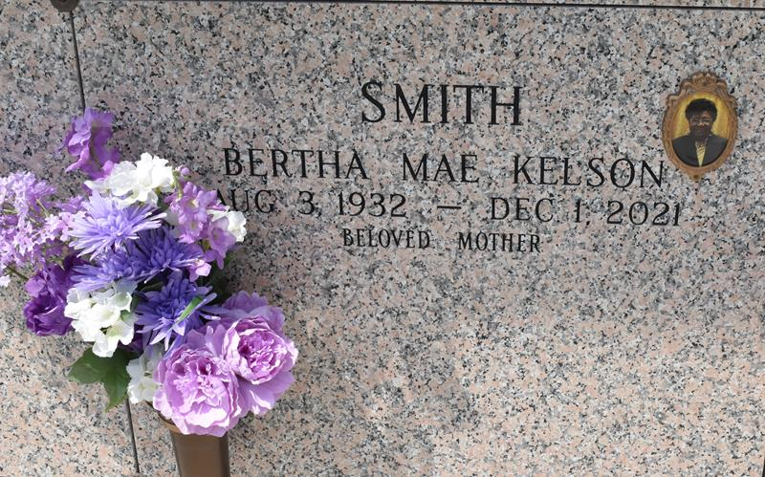

Bertha Mae Kelson Smith departed this earthly life on Wednesday, December 1, 2021, at her daughter's residence in LaPlace, LA at the age of 89.
Bertha Mae was born to the union of the late Alex and Albertha Kelson on August 3, 1932. She was the loving mother of Jaqueline P. Joseph (the late Andrew), Wanda P. Baker (Kerry), and the late Rayshawn Smith. She was the grandmother of Kerdell, Kelwin (Alisha), Kendrick, and Kerrion. She was the great-grandmother of 9. Bertha is also survived by a host of nieces, nephews, cousins and friends.
Pastors, officers, and members of New Pilgrim Baptist Church, The Powerhouse Christian Church, and Cargill Grain Elevator of Reserve, LA are all invited to attend the home-going celebration of Bertha Mae Kelson Smith on Saturday, December 11, 2021, at New Pilgrim Baptist Church, 107 Pilgrim St., Reserve, LA 70084 at 11am. Visitation 9am-11am. Rev. Dr. Forell Bering officiating. Entombment to follow at St. John Memorial Gardens, 2205 W Airline Hwy, LaPlace, LA 70068.
Treasures of Life Funeral Services, Gramercy, Louisiana

