Tierney LeChante’ Smith
June 24, 1988 – March 29, 2026

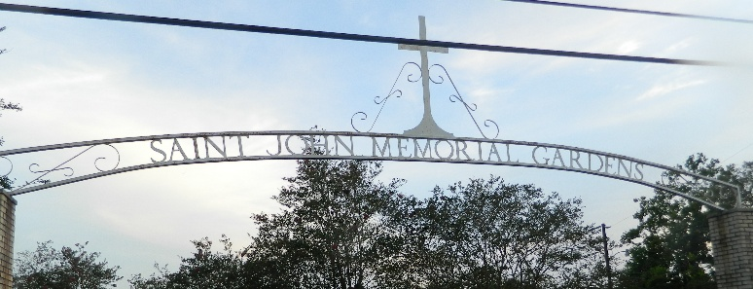

On Friday, June 24, 1988, at approximately 8:50 AM, Tierney LeChante' Smith, was born to Tiffany L. Chambers and Kevin A. Smith. Tierney graced this world with her presence to the tune of "My Girl" by the Temptations. Since then, Tierney has been a #1 song to a plethora of individuals but especially to her only child, Tiana Ashante. Tierney grew up in a loving, close-knit Christian family. She was born in Reserve, Louisiana and was a resident of Harvey, Louisiana.
Growing up in Reserve, Louisiana, Tierney built lifelong friendships and laid the foundation for her unwavering dedication to faith and family. Tierney was baptized in the Catholic Faith and, in addition to receiving the Sacrament of Baptism, she also received the Sacraments of Holy Communion and Confirmation here at Our Lady of Grace Roman Catholic Church. She attended Our Lady of Grace Catholic School and transitioned to St. John the Baptist Parish School District and was a proud graduate of East St. John High School Class of 2006 in Reserve, LA. Following high school, Tierney pursued her studies in Architecture and Engineering at The Southern University and Agricultural and Mechanical College in Baton Rouge, LA. There she demonstrated her ambition, intelligence, and determination to succeed.
In 2016, Tierney experienced one of her greatest joys in life as she became a mother and welcomed her beloved daughter, Tiana Ashante Roussell. Being a mother was one of her proudest roles. She loved her daughter deeply and unconditionally. Tierney and Tiana were inseparable- they were BEST FRIENDS.
Tierney built a strong and admirable career. She worked at ADM in Destrehan, Louisiana, where she served as a dedicated Barge & Ship Loader Supervisor until 2022. With a passion for growth and safety, she later transitioned into a new path, becoming a Safety Manager at First Student (New Orleans Branch). While there, Tierney continued to lead and inspire others through her work ethics.
Tierney was a woman of strength, resilience, and love. She was known for her kind heart, determination, and the way she showed up for those she loved. Her presence brought light into the lives of many, and her memory will forever be cherished.
She is preceded in death by her maternal grandmother, the late Elizabeth Ann Chambers; her paternal grandmother the late Jessie Mae Smith; maternal great grandmother Bernadine Stewart; aunts, Gloria, Ernestine and Kathleen Stewart and Miriam Smith-Veal; and uncle, Joseph Smith, Jr.
While at home in Harvey, Louisiana, on Palm Sunday, March 29, 2026, the angel of God appeared at Tierney's bedside and said, "My child, your work here is done". From there, our precious mother, daughter, sister, aunt, cousin, and friend, Tierney LeChante' Smith left this world and was lovingly welcomed into the open arms of Jesus.
Lasting memories of Tierney will remain in the hearts of her beloved daughter, Tiana Ashante Roussell; her loving parents, Tiffany Chambers and Kevin Smith; along with a host of family members, friends, and loved ones who will continue to honor her legacy. Tierney's life was a blessing and her memory a treasure, and she will be deeply missed beyond words.
Relatives and friends of the family, Members of Our Lady of Grace Roman Catholic Church, Deliverance Missionary Baptist Church, St. Anthony Catholic Church, St. Anthony School, ADM, First Student, St. John the Baptist Parish School District and St. John the Baptist Parish Utilities, are invited to attend a Mass of Christian Burial on Saturday, April 11, 2026 at 10 am at Our Lady of Grace Roman Catholic Church in Reserve La. Visitation to begin at 8:15am and the recitation of the rosary at 9:00am. Entombment will be at St. John Memorial Gardens Laplace La., 2205 W. Airline Hwy, Laplace, LA 70068.

Patrick H. Sanders Funeral Home, LLC., Laplace, Louisiana

