Agnes Doris (Kugler) St. Martin
July 6, 1932 – September 8, 2026

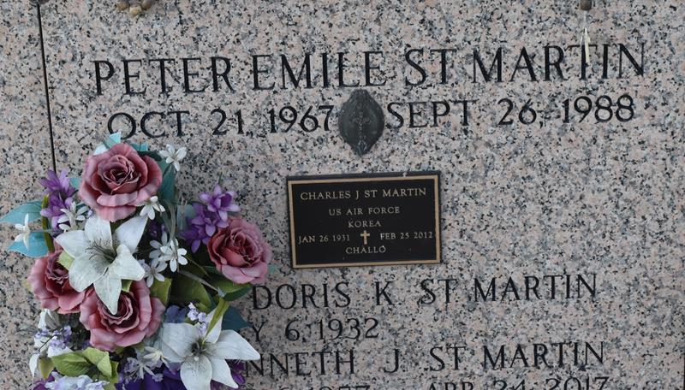

Agnes "Doris" Kugler St. Martin passed away on Monday, September 8, 2026 at the age of 94. She was a native of Norco, longtime resident of LaPlace and recent resident of Francois Bend Assistant Living.
Survived by her children; Diane Cancienne (Reid), Charles St. Martin, Jr., Jane Vicknair (Robin); Mary Holmes (Matt), Jon St. Martin (Liane); also survived by 16 grandchildren and 19 great-grandchildren; brothers, Emile Kugler and Paul Kirk Kugler (Thelma); sisters, Leona Durapau (Robert) and Saundy Weber (Mike).
Preceded in death by her husband of 60 years, Charles "Challo" St. Martin; sons, Kenneth and Peter St. Martin; granddaughter, Anna Williams; parents, Emile and Blanche Oubre Kugler; and brothers, John and Barry Kugler.
The family would like to extend a special thanks to the staff of Francois Bend Assisted Living and Memory Care.
Relatives and friends are invited to attend the Funeral Service at St. Joan of Arc Catholic Church, 529 W. 5th St., LaPlace on Wednesday, September 16, 2026. Visitation will be held from 10:00 a.m. to 12:00 p.m. with the Funeral Mass to immediately follow at 12:00 p.m. Interment in St. John Memorial Gardens Memorial Cemetery. In lieu of flowers, Masses preferred.
Millet-Guidry Funeral Home, LaPlace, Louisiana

