Leonard J. Sutton
September 7, 1932 – October 5, 2025

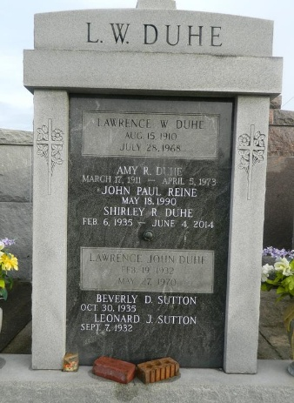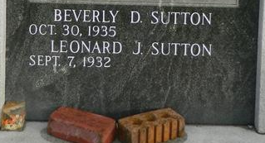

Leonard J. Sutton passed away surrounded by family at his residence on Sunday, October 5, 2025 at the age of 93. He was born in Reserve, LA and was a resident of LaPlace since 1956.
Leonard was a star football player for Leon Godchaux High School and Pearl River Junior College. Leonard proudly served his country in the U. S. Army during the Korean War. He was a master roofer by trade retiring at the age of 84. He loved spending time with his grandchildren, hunting, fishing and watching them play sports.
Beloved husband of 69 years to Beverly Duhe Sutton. Loving father of Amy Sutton Broussard (the late Daryl), Jane Sutton Reine (Kent) and the late Marlene Sutton Lions (the late David). Grandfather of Brande Lions Reyer (Jimmy), Matthew Broussard (Cher), David Lions (Shantel), Byron Broussard (Abby), Leonard "Lenny" Sutton Broussard (Casey), Amanda Lions Ortego (Kevin), Addy Reine Johnson (James), and Nicholas "Nick" Reine (Kaitlyn). Great-grandfather of 17 great-grandchildren.
Son of the late Oliver Joseph Sutton, Sr. and Lolita Weber Sutton. Brother of Raymond "Teco" Sutton, Patricia Martin, Philip "Pooka" Sutton and the late Oliver Sutton, Jr., Ruth Bourgeois, Antoinette Sutton, Norman Sutton, Ethel Champagne, Dorothy Champagne, Floyd Sutton, Lois Faucheux, Francis Gary Sutton, and Blanche Brady. Also survived by many nieces, nephews and his furry friend, Docile.
The family would like to thank everyone at Notre Dame Hospice for the kindness and care given to him during his illness. Words cannot express how grateful we are for his caregivers, Karen Sterling, Mary Breaux, Mona Lee and China for the kind and loving care given to our dad for the past year.
Relatives and friends are invited to attend the Funeral Service on Thursday, October 9, 2025 at St. Joan of Arc Catholic Church, 529 W. 5th St., LaPlace. Visitation will be held from 10:00 a.m. to 12:00 p.m. with the Funeral Mass to immediately follow at 12:00 p.m. Interment in St. John Memorial Gardens Cemetery.
Millet-Guidry Funeral Home, LaPlace, Louisiana
October 6, 2025

