Terry Steven Sympson
May 13, 1948 – November 14, 1999

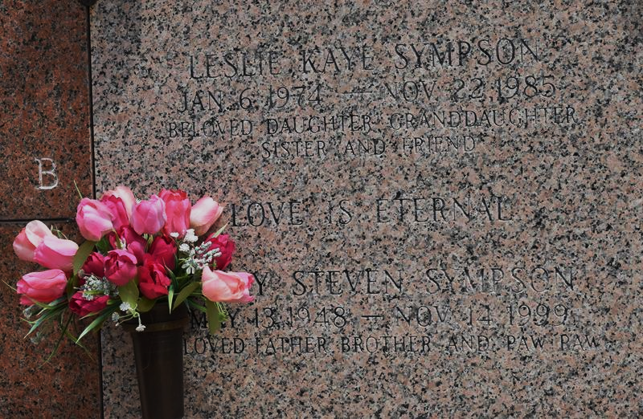

LAPLACE Terry S. Sympson, 51, a native of Illinois and a resident of LaPlace for 16 years, died Nov. 14. He was the father of Shawn Smith, Jeffrey, John and the late Leslie Sympson. He was also the brother of Carol Cruz and Christine, Kenneth, Sam and Charles Sympson. He is also survived by two grandchildren.
Services are today at noon in the chapel of Millet-Guidry Funeral Home, LaPlace, with interment at St. John Memorial Gardens, LaPlace. Visitation starts at 10 a.m.

L'Observateur, LaPlace, Louisiana
November 17, 1999

