Albert Percy Tassin
February 27, 1925 – March 21, 2004
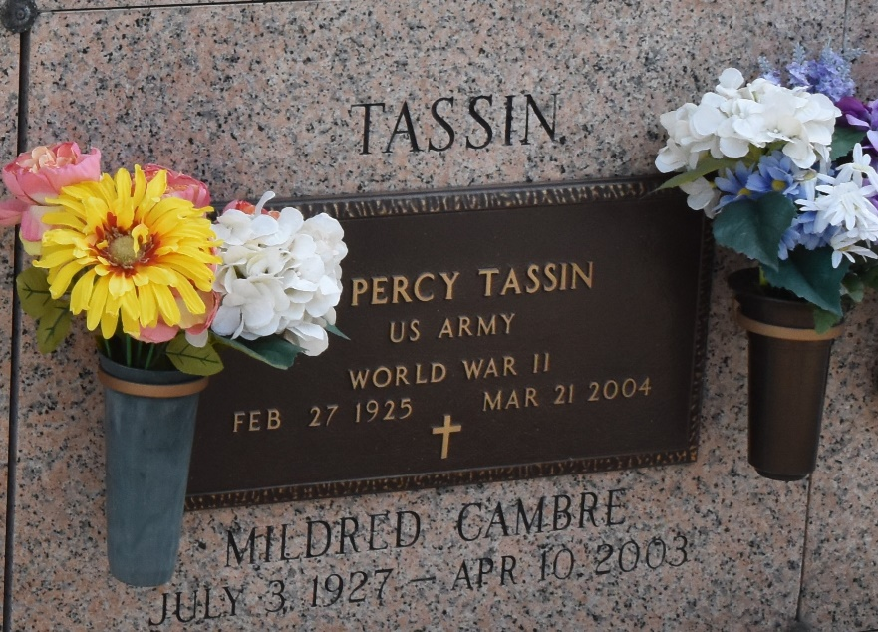

Albert Percy ""PT'' Tassin on Sunday, March 21, 2004 at 4:30 a.m. Beloved husband of the late Mildred Cambre Tassin. Father and father-in-law of Shirleen T. and Robert Biscoe, Deana T. and Charles Lee Holmes, Janet T. Frederick, Marsha T. and Joey LaBranche and Darlene T. and Thomas Dean. Grandfather of Jeffrey and Brittany Holmes, B.J. Frederick, Nicole and April LaBranche, Rebecca Day and Ryan Dean. Great Grandfather of Layla Jones. Son of the late Norbert, Sr. and Angela Jacob Tassin. Brother of the late Norbert, Jr. and Alvin Tassin, Adeline Duhe and Hilda Brock. Age 79 years. A native and resident of LaPlace, LA.

Relatives and friends of the family also members of VFW LaPlace Post 3337 are invited to attend services. Visitation at Millet-Guidry Funeral Home, 2806 West Airline Hwy., LaPlace on Wednesday, March 24, 2004 from 10 am to 12 noon.. Followed by religious service in the funeral home chapel at 12 noon. Burial in St. John Memorial Gardens, LaPlace, LA.

The Times-Picayune, New Orleans, Louisiana
March 23, 2004

