Bobbie Jean (Haselden) Toole
1931 – September 4, 2014

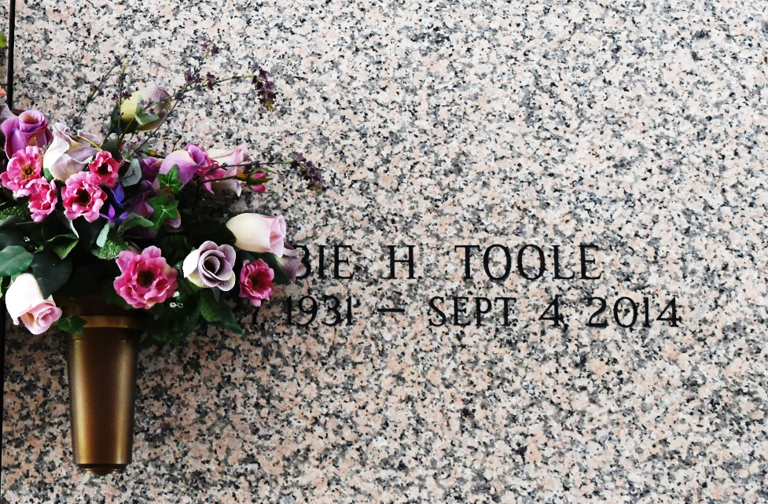

Bobbie Jean Toole went to be with her heavenly father on September 4, 2014, at the age of 82.

Bobbie is the beloved wife of Edward Thomas Toole and the loving daughter of the late Myrtice Carter Haselden and Frank Hilliard Haselden.

Bobbie is the devoted mother of Nancy T. Rome, Debbie T. Cassard and Thomas L. Toole. Grandmother of Holly Marie Cassard and Amanda Lynn Tittle. Great grandmother of Rylan Thomas Tittle.

Bobbie's presence on this earth was one of great reward to those who knew her. She will be sadly missed.

Interment is at St. John Memorial Gardens.

The Times-Picayune, New Orleans, Louisiana
Sep. 13 to Sep. 14, 2014

