Floyd N. Tuesno
March 2, 1984 – October 7, 2025

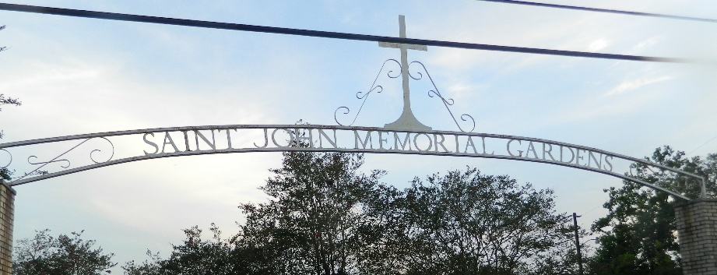

Floyd N. Tuesno, known to many as "Big Son," first saw the world on the 2nd of March, 1984 in New Orleans, Louisiana. He was the son of Mary Tuesno and Floyd Jackson and was a radiant beacon of joy, love, and creativity throughout his life.
Floyd accepted Christ at an early age and was baptized at Greater Liberty Baptist Church. He was a proud graduate of East St. John High School, class of 2001. Just as Maya Angelou once said, "My mission in life is not merely to survive but to thrive; and to do so with some passion, some compassion, some humor, and some style." This quote encapsulates Floyd's approach to life.
Floyd's earthly journey came to a close on October 7, 2025. He was greeted in the eternal realm by his grandparents, Dorothy and John Tuesno, his stepfather, Nazareth Collor Sr., his brother, Nazareth Collor Jr., his cherished stepson, Darell Mills Jr., and several treasured aunts and uncles.
Floyd found his calling early in life with a pair of shears in his hand. He went on to become an accomplished barber and cosmetologist, a talent that brought joy and style to the Lutcher, Louisiana community. With his business partner and friend, Janique Knight, he co-owned and operated Faithful Hands. His precision, artistry, and professionalism were manifested in his creative brainchild, the Wizzy Locs brand. As Confucius once said, "Choose a job you love, and you will never have to work a day in your life." Floyd's love for his craft was evident in every snip and trim.
However, Floyd's life was about more than his work. He was a man who savored every moment, a man who loved with all his heart. Whether he was cooking seafood boils, renovating houses, or sharing laughter, Floyd's genuine spirit, humor, and generosity will forever resonate in the hearts of those who knew him.
Floyd's memory will be cherished by his loving son, Floyd Tuesno Jr., his godchild, Ashari Johnson, his mother, Mary Tuesno, his father, Floyd Jackson, and his grandmother, Gail Jackson. His siblings, Joshuelle Tuesno, Eliston Jackson, and Courtney Jackson, along with his lifelong friend, Rashad Johnson, and his aunts, Melissa Tuesno Jackson, Chasity (Kiuntay) Hayes Tuesno, Jamie Jackson, Cassidy Jackson, Relinda Landry, Monique James, and Lashelle Jackson, will forever hold him in their hearts. His legacy also lives on in his nieces, nephews, cousins, and dear friends. All who wish to honor Floyd's life are encouraged to share their memories and photos on his memorial page. Your stories and images are a testament to the remarkable man he was, and they will help keep his spirit alive for generations to come.
Floyd's Celebration of Life will be held on Saturday, October 25, 2025 at St. Mark Baptist, 132 Marquez St., Mt. Airy, LA 70076 with visitation from 8am to 10am followed by the service for 10am. Entombment St. John Memorial Gardens, 2205 W. Airline Hwy., LaPlace, LA 70068.

Treasures of Life Funeral Services, Gramercy, Louisiana
October 24, 2025

