Patrick Jude Verrett
January 7, 1970 - July 27, 2024

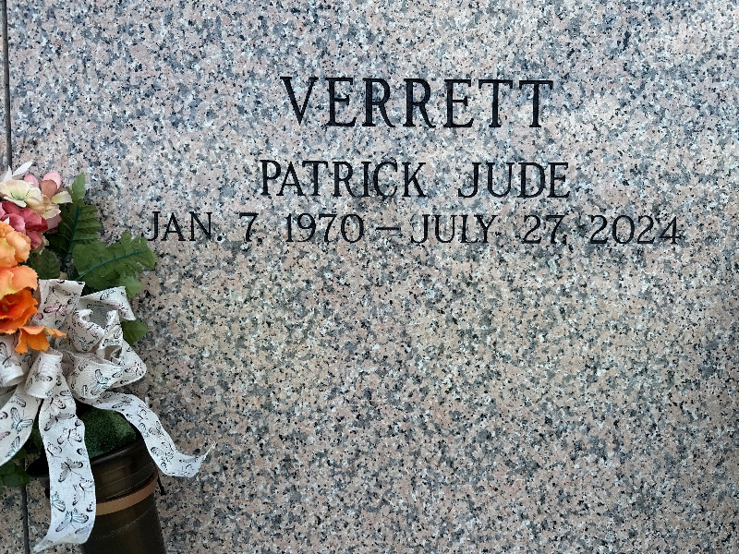
Photo by Team T-Lo

Patrick Jude Verrett, a resident of Des Allemands passed away on Saturday, July 27, 2024 at the age of 54.
Beloved husband of Kay Verrett. Loving father Quin Brewer, Shannon Brewer, and Robert Brewer. Son of Marie Reine Verrett and the late Edward Verrett, Jr. Brother of John Verrett (Barbara), Wendy Baldwin (Stephen), David Verrett (Kim), Michael Verrett (Frances), and Christopher Verrett (Dorothy). Beloved uncle to numerous nieces and nephews. Also loved by his many cousins and extended family.
Pat was a quiet and reflective man who showed his friends and family how much he cared through his words and actions. In addition to enjoying time with his family Pat was always busy working on a project around the house. He took pride in being hard-working and self-sufficient. He will be sorely missed.
Relatives and friends are invited to attend the Visitation and Funeral Mass at St. Joan of Arc Catholic Church, 529 W. 5th St., LaPlace on Friday, August 2, 2024. Visitation will be held at the church from 10:00 a.m. to 12:00 p.m. followed by a Funeral Mass at 12:00 p.m. Interment in St. John Memorial Gardens, LaPlace, LA.
In lieu of flowers the family requests you please consider making a donation to one of the following: The American Kidney Fund:
https://secure.kidneyfund.org/site/ OR The Spondylitis Association of America: https://spondylitis.org/get-involved/donate/

Millet-Guidry Funeral Home, LaPlace, Louisiana
July 30, 2024

