William “Darby” Washburn
February 2, 1968 – October 7, 2020

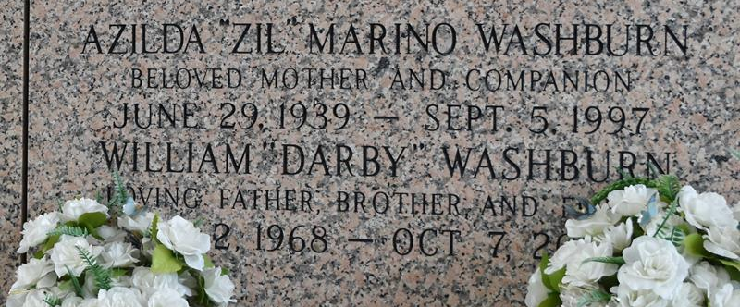

William “Darby” Washburn passed away on Wednesday, October 7, 2020, surrounded by his children and family. During his short 52 years, he accomplished many goals and enjoyed great success.
He was born on February 2, 1968, to Bill Washburn and Azilda Marino Washburn in Enumclaw, Washington. Just a few years later, his family moved to Norco, Louisiana. Darby quickly found a love for duck hunting, fishing, and even gardening by working in his grandfather’s crop fields. At 14, he started his first job at Sportsman’s store in Norco and never stopped working to help his family and friends.
At 18, Darby joined the United States Marine Corp, serving in Desert Storm and later continuing in the reserves. He landed his first big job at Shell Chemical at the age of 20. Five years later he gave it all up to bring his young family home to Morgan City to work in the oilfield where he could have the chance to make it big. Darby did just that, accomplishing every goal he ever set for himself. He made his family proud by first working his way up from tank cleaner to general manager of Coral Marine Services. From there, he went on to start his own successful businesses, including his beloved Washburn Marine Shipyard.
He loved his family and his many friends and his presence will be greatly missed by all who knew him. He is survived by his children, Alexander Joseph Washburn and Anna Leigh Washburn of Berwick, Louisiana; his brothers, Jamie Washburn and his wife, Summer, of Pasco, Washington; Bill Washburn of Priest River, Idaho; Brad Washburn of Washington; Eddie Marino of LaPlace, Louisiana; his sister, Connie Johansen of Port Orchard, Washington; and his nephew, Nathan Washburn of Pasco, Washington.
He was preceded in death by his mother, Azilda Marino Washburn of LaPlace, Louisiana and his father, William Henry Washburn of Ellensburg, Washington.
A time of memorial visitation will be held for Darby on Thursday, October 15 from 9am until memorial services which will begin at 2pm at Hargrave Funeral Home. In keeping with government mandate regarding limited gatherings, Hargrave Funeral Home can accommodate 150 guests in the facilities during the memorial visitation and 75 guests in the chapel during memorial services. All guests are required to wear a mask upon entry of the funeral home.

Hargrave Funeral Home, Morgan City, Louisiana

