Stephanie Nicole Wilking
September 24, 1983 – February 27, 2001

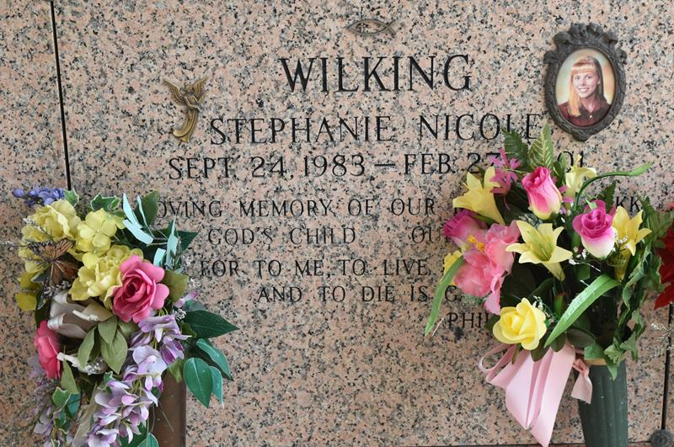

WILKING LAPLACE – Stephanie “Nikki” Wilking, 17, a native and resident of LaPlace, died Feb. 27. She was the daughter of Kevin and Paula Wilking and sister of Jason, Ashley and Kyle Wilking. She was also the granddaughter of George and Evelyn Wilking and Betty and Joe Duplessis and stepgrand-daughter of Peggy Oldom.
She was the founder of Kids for Kops while in fifth grade at Reserve Christian School, attended the 1997 National Law Enforcement Memorial Service honoring slain police officers in Washington, D.C., and earned the LaPlace Rotary Club’s 1997 Citizen of the Year award. She also found time to be active in basketball, softball, track, karate, dance, swimming and was a lifeguard at Riverlands Country Club.
Services are today at 10 a.m. at Reserve Christian Church, Reserve, with interment at St. John Memorial Gardens, LaPlace. Visitation starts at 8 a.m.
In lieu of flowers, donations are welcome to “Kids for Kops” at Louisiana Federal Credit Union, LaPlace.

L’Observateur, LaPlace, Louisiana
Saturday, March 3, 2001

