Carol Elaine (Vicknair) deBautte

December 29, 1916 – December 2, 2000

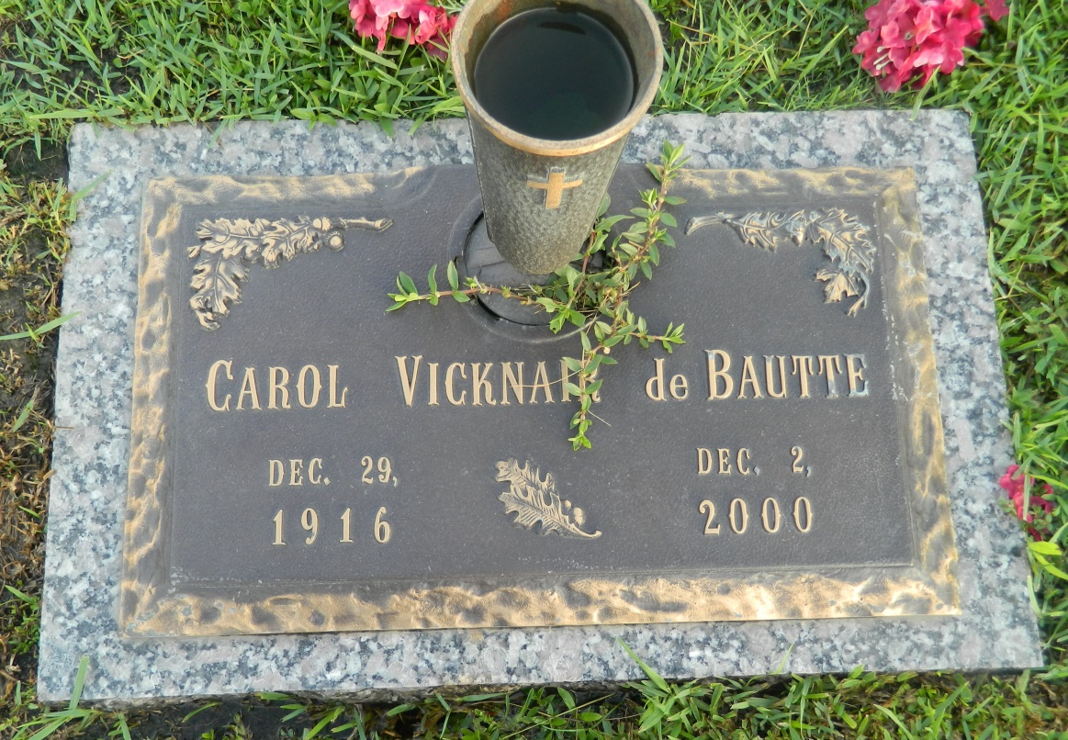

Photo by Margie Pearce

Carol Elaine Vicknair deBautte, 83, on 2 Dec 2000. Wife of the late Delton deBautte. Daughter of the late Jean Louis and Marie L. Keller Vicknair. Mother of Tanya D. Roma, Sharon D. Schultz and Charlotte D. Feola. Sister of Carmen V. Klibert, Lezina V. Guidry, Alice V. Schultz, Lois V. Saucier, Marius (Buddy) Vicknair, the late Rose V. Madere and Jean Louis Vicknair, Jr. A native of Reserve, LA and a resident of Laplace, LA for the past 22 years. Interment in St. John Memorial Gardens, Laplace, LA on 4 Dec 2000.

Times-Picayune (LA); Sunday, 3 Dec 2000