Marion Jewel (Anderson) Arcuri

April 11, 1928 – November 11, 2016

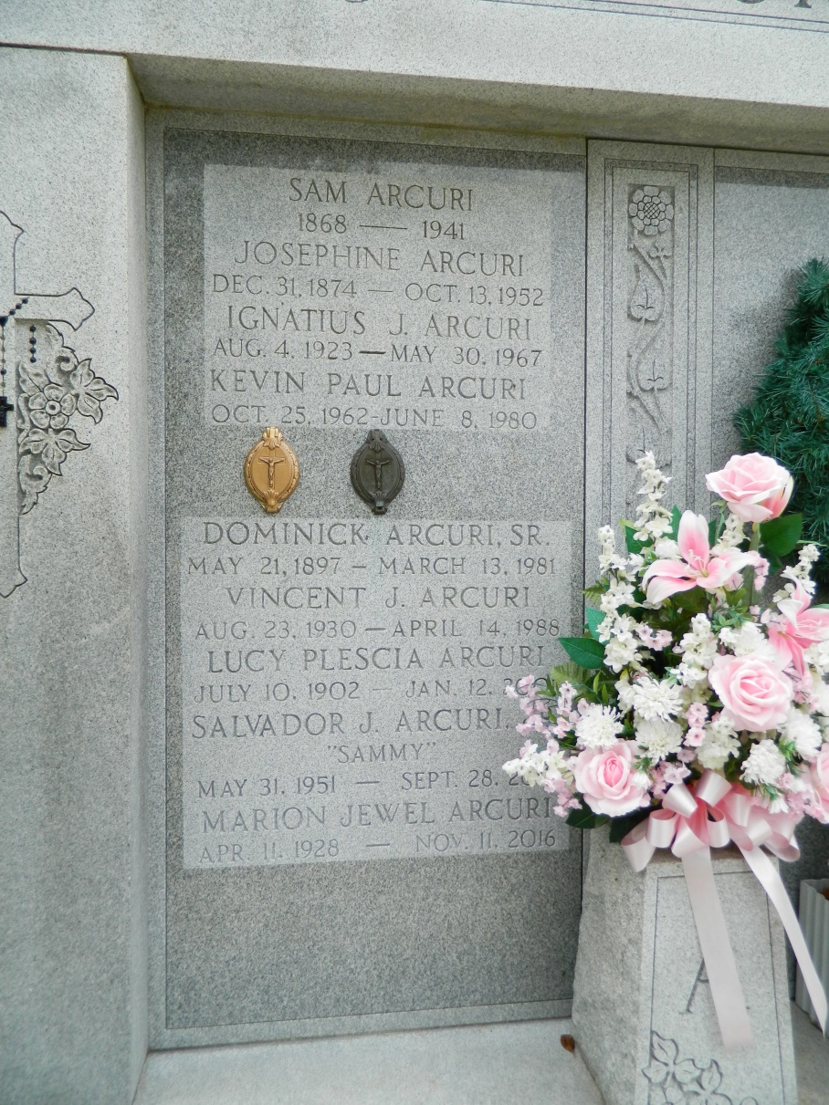

Marion Jewel Arcuri passed away November 11th, 2016 at the age of 88 with family by her side. Jewel was born April 11th, 1928 in New Orleans, La. to the late Cecilia Goode and Robert Anderson. Her early childhood was spent in Livingston, La, and later in Norco, La. As a child, Jewel attended St. Charles Borromeo parochial school and graduated from Destrehan High school in 1945. Jewel attended Spencer Business College and later worked for WR Grace in downtown New Orleans for several years. After meeting the love of her life; Dominic Arcuri Jr. "Mecu", they were married in 1948 and made their home in Laplace, La. Jewel dedicated her life to being a loving wife and mother to their three children. A lifelong member of St. Joan of Arc Catholic Church in Laplace, Jewel was active in the Ladies Altar Society and also the St. Joan of Arc Thrift Shop. Wednesday afternoons were set aside for the weekly Card Club. Catching up on the latest news around town was always more important than the pennies that were wagered on the card game. Jewel will be sadly missed by her many friends and relatives that she shared her love, compassion and kindness with. Jewel is survived by her husband of 68 years Dominic "Mecu" Arcuri Jr, three sons, Dr. Dominic "Nick" Arcuri III (Renee'), Robert "Robby" Arcuri (Jenny), and the late Kevin Arcuri. Jewel is also survived by five grandchildren; Erin Hubert, Andrea Hoover (Richard), Dr. Michael Arcuri (Fiancé, Iracema Aleman), Monica Walker (Lance) and Dominic "Nico" Arcuri, IV. There are also three great grandchildren; Haley Hubert, Davis Hubert and Lucy Walker. Friends and Relatives are invited to attend the services at St. Joan of Arc Catholic Church, 529 W. 5th St., Laplace. Visitation will be from 9:45 am to 12:30 pm on Tuesday, November 15th, 2016. A Memorial Mass will begin at 12:30 pm and burial will follow at St. Peter Cemetery in Reserve, La. In lieu of flowers, masses preferred. Arrangements by Millet-Guidry Funeral Home. To view or sign the online guest book, please visit [www.milletguidry.com.](http://www.milletguidry.com/)

Published in [TheNewOrleansAdvocate.com](http://theneworleansadvocate.com/) from Nov. 12 to Nov. 15, 2016

Contributed by Jane Edson