Salvador J. Arcuri

May 31, 1951 – September 28, 2012

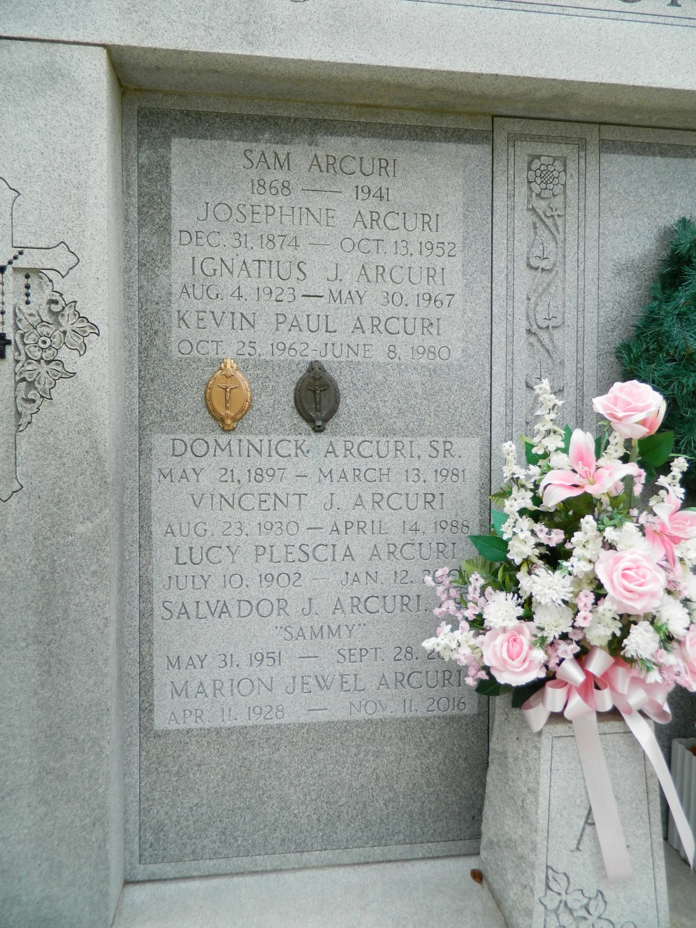

ARCURI Salvador (Sammy) J. Arcuri Jr. passed away on Friday September 28, 2012. Beloved father of Marci Arcuri and Gina Arcuri McNemar (Mark). Son of the late Salvador (Sam) and Luella Babin Arcuri. Brother of Dominic (Mixie) Arcuri (Tru) and Gaye Lambert (Randy). Also survived by nieces and nephews. Age 61. A native and resident of LaPlace, LA. Relatives and friends also St. John The Baptist Sheriffs Dept. are invited to attend services. Visitation at Millet-Guidry Funeral Home, 2806 W. Airline Hwy., LaPlace, LA on Monday October 1, 2012 from 5:00 pm to 9:00 pm and on Tuesday from 8:00 am to 9:45 am, followed by Mass at St. Joan of Arc Catholic Church, LaPlace, LA at 10:00 am. Burial in St. Peter Cemetery, Reserve, LA.

**Contributed by Jane Edson – no source listed**