Eric Stephen Aucoin
February 14, 1971 – September 17, 2014

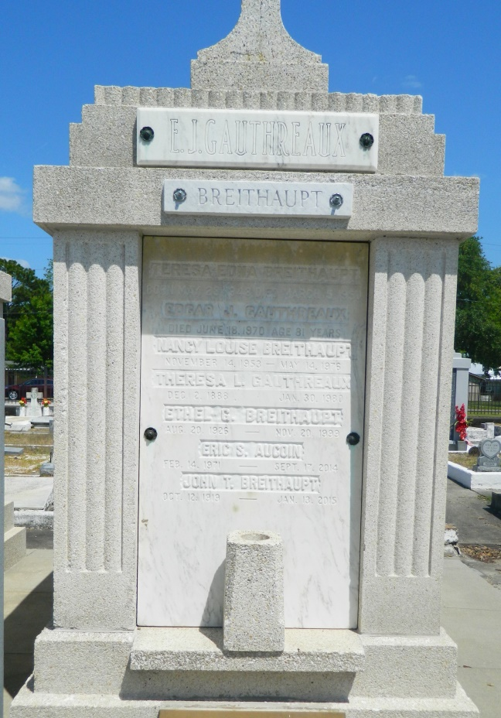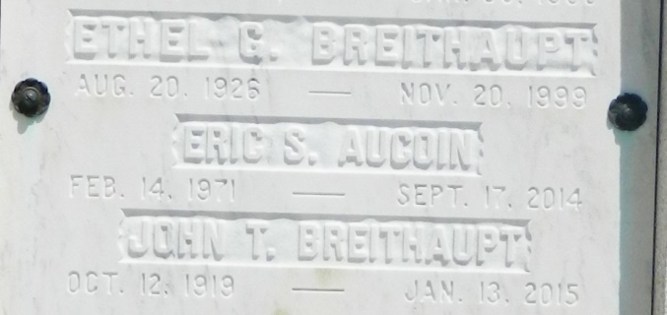
Eric Stephen Aucoin, a native of Houston, TX and a resident of Algiers, LA, died September 17, 2014 at the age of 43. Beloved son of Alice Breithaupt Aucoin and the late John B. Aucoin. Brother of Jennifer A. Eckhart (Corey). Grandson of John Breithaupt, the late Tiny Breithaupt, Mavis and John Aucoin. Nephew of Lisa and Luke Clayton of Dallas, TX. Also survived by his beloved nieces, Peyton and Piper Eckhart, and a host of cousins, family and friends.
Eric was an extremely devoted Saints Fan and proud member of the Who Dat Nation. He also was a musician who played with various area bands over the years.
Relatives and friends of the family are invited to attend the Memorial Visitation at MOTHE FUNERAL HOME on Friday, September 26, 2014 from 11:30 AM until 1:30 PM. The Memorial Service will follow at 1:30 PM. In lieu of flowers, donations may be made in Eric's name to White Dove Fellowship, www.whitedove.org. For further funeral information or to sign the online guest book, please consult www.mothefunerals.com.
Times-Picayune, The (New Orleans, LA) - Friday, September 26, 2014
Contributed by Jane Edson

