Frank Omer Battard, Jr.

September 9, 1921 – March 21, 2010

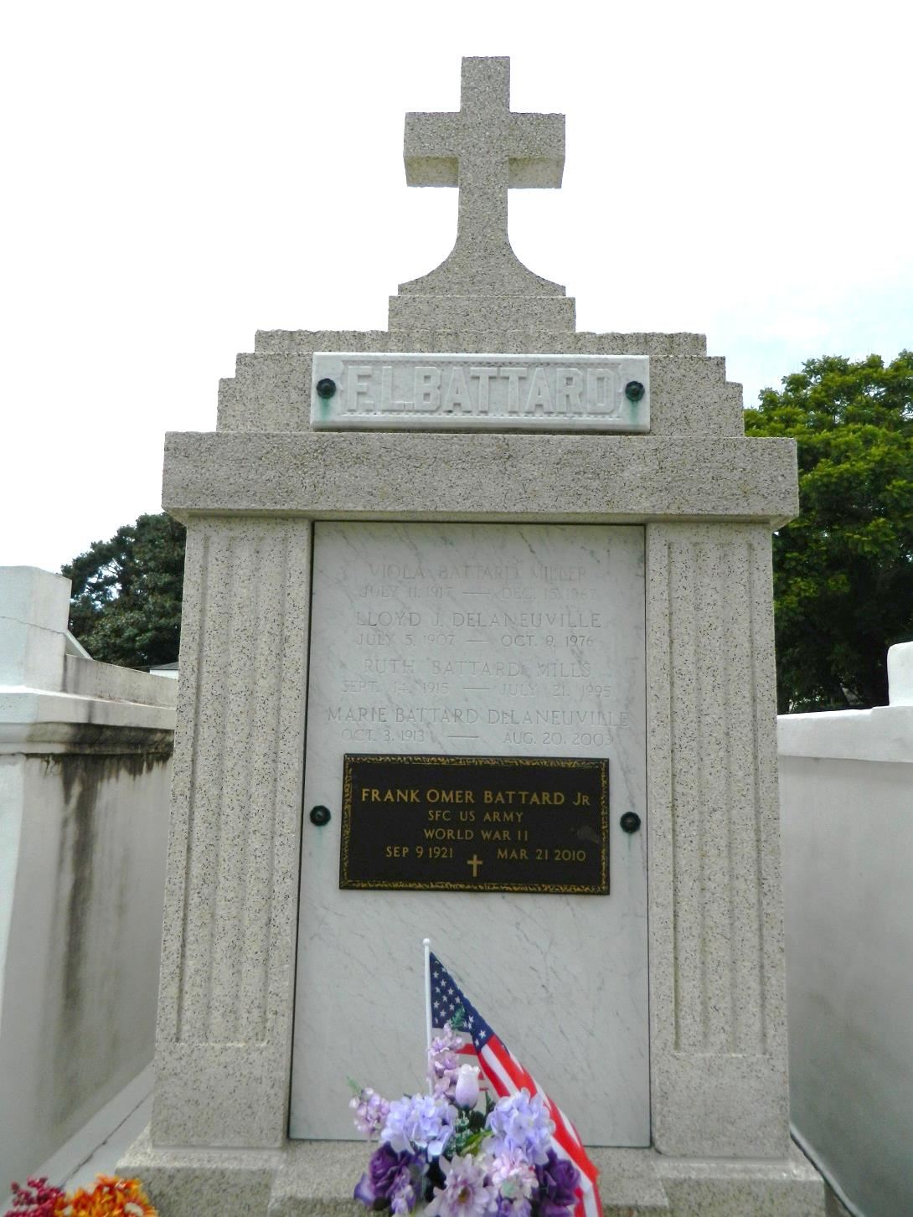

Frank O. Battard passed away on Sunday, March 21, 2010. Beloved husband of Lotte Battard. Father of Frank P. and David P. Battard. Also survived by 6 grandchildren and 5 great-grandchildren. Brother of Therese Picton. He was a sergeant in the U.S. Army during WWII and retired after 21 years. Also, he retired from the State of Louisiana with the Department of Health after 20 years. Age 88 years. A native of Reserve and a resident of Kenner.   
 Relatives and friends are invited to attend services. Visitation at Millet-Guidry Funeral Home, 2806 W. Airline Hwy., LaPlace, on Wednesday, March 24, 2010 from 9:00 AM until 11:00 AM. Followed by Religious Service in the Funeral Home Chapel at 11:00 AM. Burial in St. Peter Cemetery, Reserve.

Times-Picayune, The (New Orleans, LA) - Tuesday, March 23, 2010

Contributed by Jane Edson