Daniel Elmore "Danny" Becnel, Jr.

June 14, 1944 - April 7, 2020

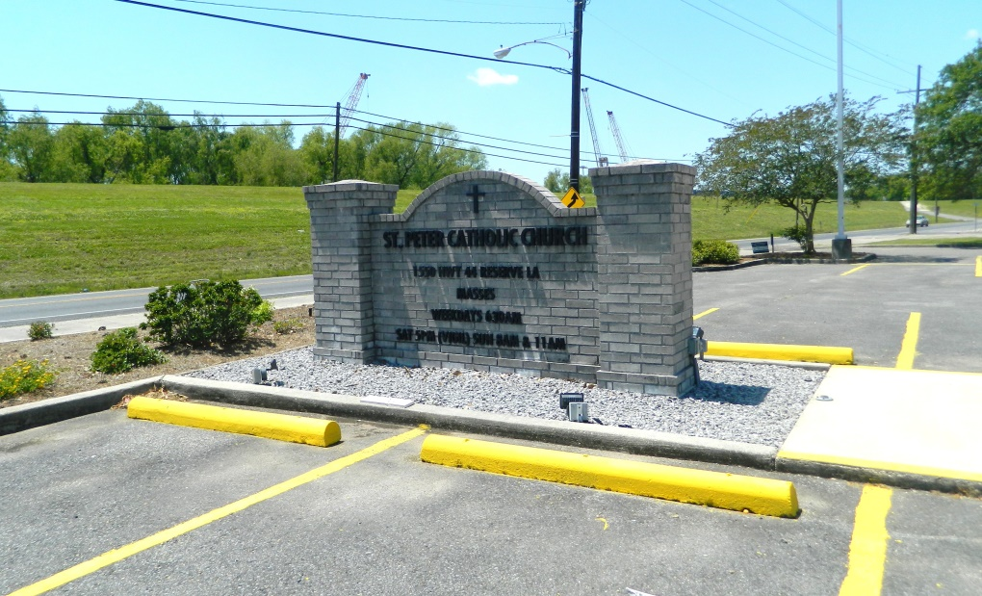

Daniel Elmore “Danny” Becnel, Jr., age 75, passed away at his home in Laplace on April 7, 2020, after a long illness.  
 He was the son of Daniel Elmore Becnel, Sr. and Edna Vicknair Becnel. He is survived by his wife of 42 years, Mary Hotard Becnel; four sons, Daniel Elmore Becnel III (Kathryn), Christopher Devon Becnel (Toni), Bradley Douglas Becnel (Ashley), and Ainsley Michael Becnel; and his sister Susan Williams and brother Robert Becnel. He was the grandfather of seven grandchildren, Jane, Christian, Thompson, Nicholas, Connor, Evan and Bryce Becnel, and the uncle of numerous nieces and nephews.  
 Danny attended St. Peter Catholic School in Reserve, graduated from Holy Cross High School, obtained a BA from LSU and a JD from Loyola Law School. Danny practiced law for more than forty years, maintaining offices in Reserve and Laplace. As a young lawyer, he won the first million-dollar personal injury jury trial in Louisiana and became a very successful and nationally renowned trial lawyer for personal injury, class actions and multi district litigation.  
 His work took him across the country and into contact with dignitaries and presidents, but he was a country boy at heart, always happiest to be back in his beloved St. John the Baptist Parish. He could often be spotted working in his garden and riding his tractor. He was a generous man with a bigger than life personality who touched many lives.  
 Services will be private, but a memorial service will be held at a later date. In lieu of flowers, please consider a donation to medical health professionals in need of assistance.

Millet-Guidry Funeral Home, LaPlace, Louisiana; April 8, 2020