Fernand A. Becnel Jr.
June 23, 1948 – August 26, 2014

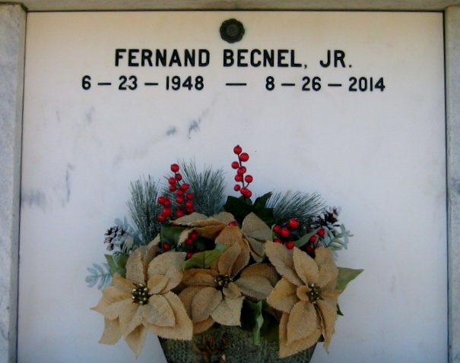
Photo by Bobby

Fernand A Becnel, Jr. "Fern" born on June 23, 1948, entered into eternal rest with his Heavenly Father on Tuesday, August 26, 2014. He was 66 years old.
Son of Audrey B. Becnel and the late Fernand A Becnel, Sr. and brother of the late Nathan Becnel. He is survived by his loving companion Patricia Broussard and brothers Michael C. (Deborah), Dale L, Glenn J., Brian M., Kent T (Delaine), and Shawn P. (Clair) and sister Daphne (Ed) Hebert. Beloved uncle of many nieces and nephews who share his love of nature.
Fernand was born in Reserve, LA where he grew up and attended St. Peter School. He graduated from St. Joseph's Abbey and Nichols State University. He worked at Godchaux and Colonial Sugar Refineries and Nalco at various times in his career and retired from Stockhausen. Fernand was a dedicated hunter and loved to be outdoors and was a certified hunting instructor. Fern was a marksman and was active in many shooting activities at Nick's Shooting Range.
TheAdvocate.com
Aug. 27 to Aug. 28, 2014

