James Leon Bergeron Jr.

December 3, 1934 – December 2, 2008

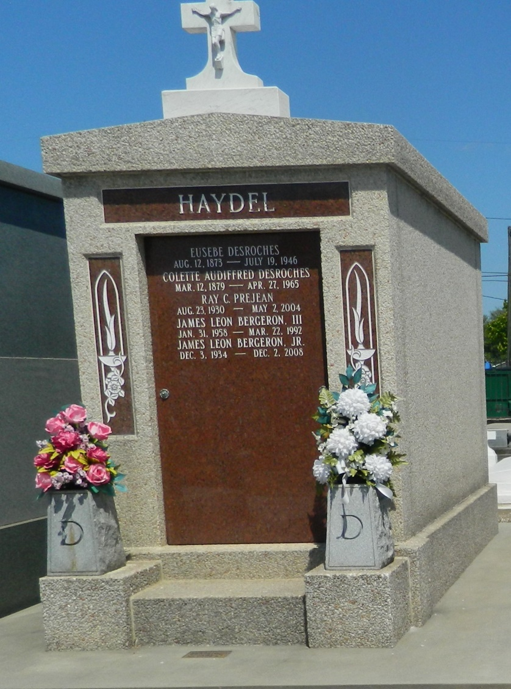

James (Jim) L. Bergeron, Jr. died peacefully at St. Mary's Hospice House on Tuesday, December 2, 2008 at the age of 74 after a lengthy illness. Jim was born in Franklin, LA on December 3, 1934. He was a graduate of Franklin High School and Tulane University. He was retired from Chevron Oil Co. where he had worked for 35 years, and had served 12 years in the Louisiana National Guard. Mr. Bergeron was preceded in death by his son, James L. Bergeron III; parents, James and Gertrude Bergeron; and a brother, Ralph Bergeron. Mr. Bergeron is survived by his wife, Gay Haydel Bergeron; daughters and sons-in-law: Beth and Michael Zagata and Cindy and Michael Ryan, daughter, Nancy Barron; grandchildren: Dustin Barron, Lani Nelson, Corey Barron, Rebecca, Michael, Stephen, and Matthew Ryan; great-grandchild, Jaxon Barron; and siblings: Aubrey Bergeron and Mary Ann Keegan.  
 A Memorial Mass will be held on Tuesday, December 9, 2008 at 10:00AM at St. Peter's Church, 168 West 7th Street, Reserve, LA 70084 with interment in St. Peter's Church Cemetery. The family respectfully requests flowers be omitted and donations made in his memory to St. Joseph Catholic Church Building Fund or St. Mary's Hospice House, Athens, GA.  
 Little-Ward Funeral Home, Commerce GA in charge of arrangements.

Times-Picayune, The (New Orleans, LA) - Sunday, December 7, 2008

Contributed by Jane Edson