Clarence "Peto" Antoine Berthelot Jr.

July 28, 1945 - December 19, 2019

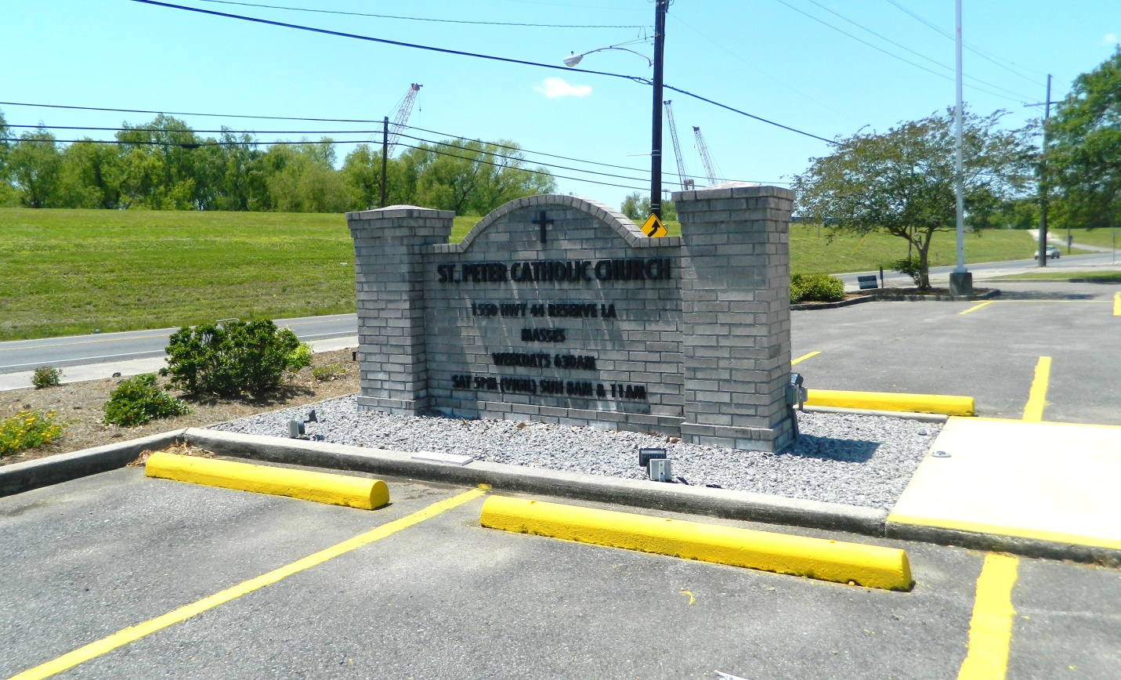

Clarence “Peto” Antoine Berthelot, Jr. passed away on Thursday, December 19, 2019 at the age of 74. He was a native and lifelong resident of Reserve, LA. Peto honorably served his Country in the U. S. Navy during the Vietnam War. He was awarded the Bronze Star and National Defense Medal for his bravery by saving his fellow servicemen on the U.S.S. Forrestal. He loved watching LSU, Miami Dolphins and Saints football. He enjoyed spending time with his friends telling stories and playing games.  
 Father of Dolores Berthelot Montz (Steven), Rebecca Berthelot Simon (Kevin), Travis Paul Berthelot (Alana) and Jeremy Robert Berthelot (Amy). Grandfather of Kaylyn Montz, Braedon Montz, Chloe Simon, Kelson Simon, Corinne Simon, Ava Berthelot, Brady Berthelot, and Anna Cate Berthelot. Former husband of Loretta Robert Webre. Son of the late Clarence Antoine Berthelot, Sr. and Evelyn Jacob Berthelot. Brother of Robert “Bob-Roach” Berthelot (Carla), and the late Alan “Eboo” Berthelot (Mary Lee) and Lawrence “Tenon” Berthelot (Evette). Also survived by his three Godchildren, Cindy Berthelot Faucheux, Eric Paul Berthelot and Josette Trosclair Oubre, and many nieces and nephews.  
 The family would like to give a special thanks to the staff of the War Veterans Home, Ochsner Kenner, E.J. and Susan Guidry for their care, comfort and assistance.  
 Relatives and friends are invited to attend the Funeral Mass at St. Peter Catholic Church, 1550 Hwy 44, Reserve on Thursday, December 26, 2019 at 11:00 a.m. Visitation will be held in church from 9:00 a.m. until 11:00 a.m. Interment in St. Peter Cemetery. In lieu of flowers, please consider a donation in his memory to the Southeast Louisiana War Veterans Home Activity Fund or Perry’s Posse

Millet-Guidry Funeral Home, LaPlace, LA; December 21, 2019