Stacey Aline (Taylor) Berthelot-Kyzar
July 26, 1921 – June 13, 2006

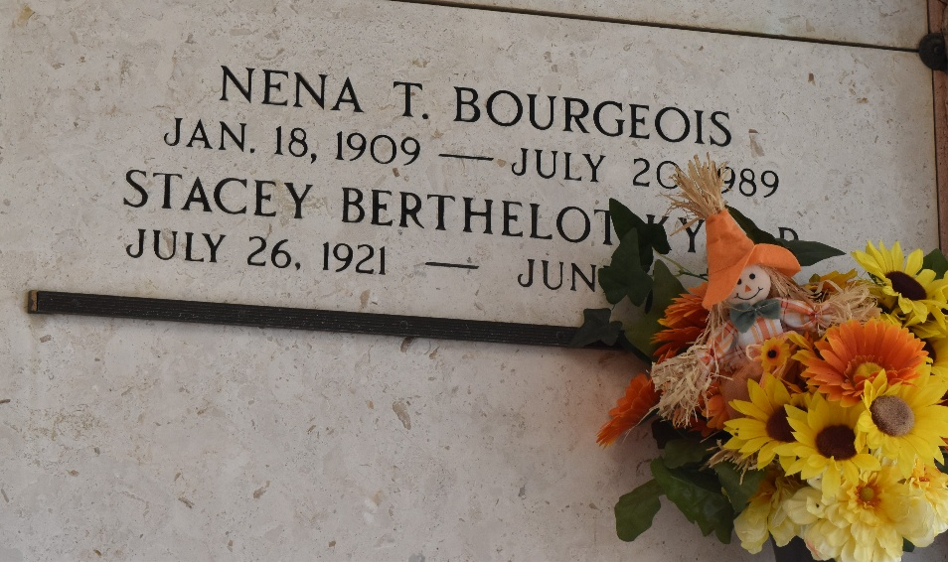

Stacey Berthelot Kyzar on Tuesday, June 13, 2006 at 3:45 p.m. Beloved wife of the late Edward Kyzar and by first marriage of the late Joseph Berthelot. Daughter of the late William and Stella Taylor. Sister of Elizabeth Stevens. Also survived by nieces and nephews and great-nieces and nephews. Age 84 years, a native of DeRidder, La. and a resident of Reserve, La. for the past 67 years.
Relatives and friends of the family, also the American Legion are invited to attend services. Visitation at Millet-Guidry Funeral Home, 2806 W. Airline Hwy., LaPlace, La. on Thursday, June 15, 2006 from 11:00 a.m. to 12:45 p.m. Followed by Religious Services at St. Peter Catholic Church, Reserve at 1:00 p.m. Burial in Church Cemetery.

The Times-Picayune, New Orleans, Louisiana
June 15, 2006

