Stacy (Brady) Boe
November 4, 1962 – January 17, 2004

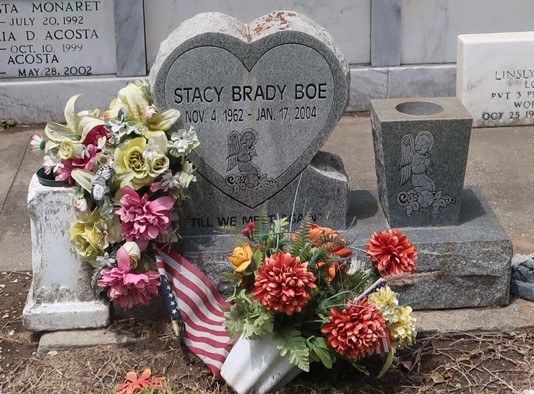

Stacy Brady Boe, A Sales Person For America's Best Manufactured Homes, Died Of An Automobile Accident In Gramercy On January 17, 2004. Age 41 Years. A Native Of Garyville And A Resident Of Gramercy, La.
Survived By Her Parents, Forest J. Brady. Step-Mother Dolores Brady And Mother Lavonne Brady. Sons, Dain Boe And Trent Boe. Brothers, Kirk Brady, Sr. And Forest Brady, Jr.
Relatives, Family And Friends Are Invited To Attend Services On Monday, January 19, 2004 At 10:00am At H.C. Alexander Funeral Homein Lutcher. Burial In St. Peters Catholic Cemetery, In Reserve, La. H.C. Alexander Funeral Home In Charge.
Times Picayune, New Orleans, Louisiana
January 18, 2004

